Northern Lights aren't simply part of ‘cosmic radiation’ but are mostly a phenomenon of Uranium in the water cycle. The Vikings may have called the place ‘Greenland’ due to the colour of the northern lights, but what if you had the logic to understand the Sun itself is a continuous northern light?

ICE LIGHTS
Old timer ‘root-cellars’ had water barrels that froze when it was too cold. Northern lights are similar, but in the sky. Flaring denotes both freezing and perhaps atmospheric friction.
Northern lights combine uranium chalk (for green lights), water, and collapsed balloons of atmospheres in the far north. At minus 35 degrees Celsius (C) or so, gaseous lights turn to icebergs and float in the sky.

Think of these terms:
- Ice lenses
- Tesla’s atmospheric friction electrical generation (7 atmospheres)
- ‘Root- cellar’ water barrels
- Rivers- in- the- sky ...and think of Galileo, the Toronto School Board of Education, Copernicus, and ...GURBIN!

A book by C. Luke Gurbin
app2app@ymail.com

Tableau Du Contents, avec les page numeros
2 … This page, this very one you are lookin' at (says this ‘wolverine- tanked-Chillbilly’)
3 … Preface, Disclaimer and the book ISBN
4 … Intro
7 … Background
9 … Dedications
10 … Luke's observations of a northern microclimate
10… CHAPTER ONE: A Maverick book
15… CHAPTER TWO: What if H2O is mixed with radioactivity?
23… CHAPTER THREE: Canada really is ‘Bloody Canada’ as was ‘little France’, aka ‘Bloody Scotland’. Or: So I think URANIUM is in the hydrology cycle.
32… CHAPTER FOUR: I’m baffled by this all… & older bro says “more iodized salt”.
42… CHAPTER FIVE: Snow White’s Palace for a Disney destination.
50… CHAPTER SIX: Lynn Andrews needs to move her people- not only because no one I’ve heard of has tried corralling Muskox (twice the iron content of bison).
57… CHAPTER SEVEN: ICE LIGHTS! and moondogs and skyquakes- OH MY!
64… CHAPTER EIGHT: Save the Queen, not the Wi-Fi.
71… CHAPTER NINER: The un-named 2000’ highpointed Stoney Mountains of Kug/ Coppermine to Churchill that hold the weather in, as in- ‘in’sanely cold (locally named).
77… CHAPTER X: Green mud forming around a small green chalky pebble- it’s a water-soluble-dissolving-pebble in a wet puddle.
81 … Epilogue
83 … Conclusions and Future Vision, Web list of ten pertinent northern light websites
84 … Maps for the book of ice lights
90, 91 … Possible back covers for the book

Preface
My Dad enjoys my silence. He doesn't care if I am irradiated. His service is to the nuclear industry and its' hold on my hometown. I grew up in the silence, left it, and didn't care for it. Politicians don't care about truth. Politicians want conflict, and have cut off
the Wollaston band Indians from welfare when any protests of the uranium industry
mining occurs. The military industrial prizes its' weaponry and technology without question.
I became an organic farmer because the farming industry and technology pride are all very unreal.
Politicians don’t care about truth. For the record, they have relentlessly used politics to destroy
The Rule of Law. It started with Clinton and ‘Echelon’ thinking the citizens could be kept in line. When
politicians destroy the Rule of Law, blatantly, it sucks. Contenders can view such websites as www.mprofaca.cro.net/echelonfr.html and also www.aboveblack.com as Clintonians can’t handle internet connectivity of determined citizens demanding a functional rule of law. My Dad can’t understand how they try to silence me, but then again, I never told Dad how I exposed the Vince Foster, Jerry Parks, and Kathlene Wiley’s husband ‘problems’ of the C-regime. They also will never stop hating me, nor will their druglord in Arkansas, codenamed ‘chickenman’ as Paul Anderson distributes drugs through half the USA with the colonel’s KFC.

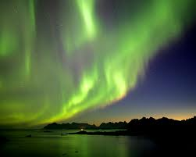

Disclaimer
Neither reprints nor reproductions of this work allowed. Permission for such activity must be directly obtained from my person directly, and not by telepathic fantasy. You don't arrest me for perceived crimes; you cannot reproduce this work similarly without direct, actual, physical permission. Should you utilize this information in any means, it is your responsibility. Don't steal my efforts and do not blame me. And please, do click the following and listen while you read, if possible.
http://www.visitnorway.com/northern-lights
ISBN # 978-0-9878980-4-3

Ice Lights is copyrighted and self-published by C. Luke Gurbin, all rights reserved, in this first edition, 2013, Creston, BC. Yet ecopy is complete at the U of Guelph, in Guelph, Ontario, Canada, back home. Contact for Luke is email: app2app@ymail.com

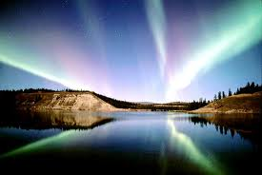

Intro
From approximately Dec 1/2012 to mid- may year 2013, I was very fortunate to have the unique experience of being a winter caretaker for Ennedai Lake Lodge, Nunavut territory, Kivaliq region.
For about five months I had a wood burning stove on the edge of Canada's northern tree line to keep from freezing to death. I was supplied with proper gear to live through temperatures ranging from +15 C to a low of - 55 C, very cold! I was provisioned both at the camp and also upon being flown in. I planned to ice fish but ten feet of ice is tough to get through when a back injury prevents ‘quick- pull’ actions needed to start a power auger and also a snowmobile. I called HQ in Resolute Bay, or in Iqaluit, twice a week sometimes only getting through once (the local term is being 'weathered out').
I saw foxes, singular wolverines (purposeful tanks that can take out a grizzly), lots of birds, northern lights, sundogs, moondogs, green snow, blue snow, and many northern experiences unfathomable to southern warmer eyes. It is often hard to recall those eyes upon returning south, such is the absolute wonder I have witnessed in the north. I melted snow near the wood stove I had moved over a bit on its' firepad area so I could sleep next to it when -40 C hit the area with winds. I made a home for myself and could imagine the area logged and put to fields and orchards for human habitation I am familiar with. The Viking Empire also similarly is said to have expired by doing many old things in a new region, but who would ever guess that "Greenland" was named after the green northern lights? I call the Northern Lights as nls… repeated in this entire book.
http://en.wikipedia.org/wiki/Ennadai_Lake
Strangely, past minus forty, all cold was a similar experience. I won't boast this or anything...but northern science is different. What if past minus forty isn't minus forty on the south thermometer mercury scale?
Dry cold is one thing, and I had it at the extremes, but what if...You'll become acquainted with me questioning science during this entire booklet. You think that we can just settle on a few things. Your traditions say it must be so. You'll say that the heavens and firmament are set.
I'll wax poetic, barb a quip and act silly. This is a place to read with perspective, if you don't have any, don't complain to me, go live somewhere else for a year or two, I lived some of West Canada, and am able to identify traditions there and Ontario's innovative behaviour in spite of both places having Catholic and freedom loving English sentiments.
I was provisioned at both the camp site itself (a generous larder) and upon being flown in with a set of supplies that sooner were diminished). Professor Thomas F.X. Noble is the Robert M. Conway Director of the Medieval Institute and professor of History at the University Of Notre Dame.
http://www.thegreatcourses.com/tgc/courses/course_detail.aspx?cid=370
In his 'Foundation of Western Civilization’ series through the Great Courses company (advertising in popular science, the economist, and other wonderful mind opening pieces of literary wealth) Doc Tom states the consequence of the second parceling of Rome after Diocletious and under Constantine (from York, England) was that while Byzantine (‘rulers of Rome’ in the Greek language) became strong, Rome became 'Ecclesiastic' or religious. In other words, Western Rome learned to flourish words like I am doing at the moment. Guess I better show the Gurbin namesake and be a Byzantine.
I planned to ice fish but ten feet of ice is tough to get through when a back injury prevents the quick-pull action required for a power auger start or even starting the engine of a snowmobile, a car of the north. I really did learn a great deal while in the north, though it seemed slow and often only in hindsight. I never would have fathomed that the millions if not billions spent by the USA on its' super highway project was something unrequired in the north.
Have snow, will travel. Ever see a $10,000 snowmobile? I’ve never owned a car beyond two- thousand dollars, and unable to pull-start the growling engine of Quebec’s contribution to outdoing the English in North Am, the snowmobile is an exquisite form of art only seen in golf courses and pubs outside of the North’s menacing glare that falls all detractors from the cold embrace of what Russia calls "General Winter". She be sleek, this general, so I am betting the bombardier club renamed General to Generalisima one day and took her for a ride.
I called HQ twice a week, sometimes less when all weathered out. Weather at E Lake is From Lutselke, renamed into modern Snowdrift or Snowball for the south tourist crowd, but you could fit Yellowknife weather into E Lake- for 3/4 of the year only. For the other 1/4 of the year, we are worse that Resolute Bay. The area, according to Rand McNally 1972 atlas views of climate, is a place of extreme cold. Here I must may a correction dealing with weather affections such as the one called the tree line. The tree line I was on wasn't the one north of me. Okay, so get used to this idea, there isn't just one, right? No one big bang, no one Yahweh, but more than one. So the other tree line the Inuit in the Baker Lake area have huddled over their new border with NWT into Kivaliq is there.
Most won't understand the north Kivaliq region border. It doesn't follow the non- labelled ‘Stoney Mountain’ range from Kug/Coppermine to Churchill nor does this tree line make any sense except to the Baker Lake blokes that go out every season to look for wood. They tell the wife they are going for wood.
The map says the trees are just south of Saskatchewan’s border and so the Baker’s Lake gents disappear for month to ....right next to Baker Lake in to Muskox reserve that only locals can hunt. Musk ox is twice better in iron than buffalo and buffalo is twice better than cow meat. We get tougher in the tough. So the Man goes a few hundred kilos away, not a thousand. Think the polygamy of the north is famous for its monogamy or its cannibalism? Maybe Washington belongs in Bakers' Lake. Baker's dozen wasn't perhaps referring to bread alone. Personally, I prefer the non- insane monogamy.
I saw foxes, a wolverine, lots of birds, northern lights, sundogs, moondogs, green snow, blue snow, and many northern experiences unavailable to the southern comforts.
http://www.wunderground.com/weather-forecast/CA/Ennadai_Lake.html
They say a successful story has a love story in it, says Dawn Steele. Dawn Steele is a famous Jewish woman who doesn't suffer the likes of Spike Lee snubbing her without letting the fellow know he's off base thinking she's a ‘white ho’ and not a ‘Jew white ho’. Creoles think they can destroy our dignity without recompense. I believe in the Byzantine quarter system, love my Philippine in-laws, but think the slavery ethics of other cultures is best controlled by the quarter system of the old world city system. I mean, if the racism destroys inner city Detroit, you move, it destroys Cleveland, you move to the burbs. Racism pretends to be communism, you move outta Buffalo to the outlying towns, but when Russia pays racism to destroy New York as well as target Democracy, you think the thugs would care about preserving their ability to rally at Ennedai Lake to protest uranium mining.
I melted snow near the woodstove I had moved over a bit on its' firepad area so I could sleep next to it when minus forty hit the area with winds. And this wasn't severe until the start of January period, then again in March. So the weather at Baker Lake forms a tree line, but also an extreme low that doesn't reach to Resolute Bay. I’ve been studying maps. Even a weather station 10 kms away according to AZ didn't reveal a whiteout ‘snowblow’ drop his computer detected.
Amoung the northern Lights, I think my director wondered for my sanity for the sake of the bottom dollar sale of his tourist money. Funny what an echelons systematic degradation of citizens can do in an isolated outpost to employee relationships.
Some people got a preliminary for this book, a first draft, to see how they'd respond to it. Maybe the Queen and Duke of E awards for scientific discoveries could one day be a high.
I think Az (the operator) and his bottom line are compromised by a young manager's family financial glory and Az’s lack of another partner in his northern enterprises.
http://derekandsuepanacea.blogspot.ca/2013/07/week-1-nunavit.html
In all, I made a home for myself, envisioning solar flares dissolving the south and my emergency route to chesterfield inlet and Ranklin Inlet as a way to have free housing now abandoned by relocated and now moneyed locals. I imagined this E Lake as a fielded area for easy corralling of caribou into a bottlenose feature of the area for easy slaughter.
I imagined where Saskatoon berries could be grown in acres, and even saw the cranberries at my feet in the last week on location. Alien craft descended through the clouds on foggy day to monitor me with their 3 lights in a row transponded problems and I suppose I shouldn't talk as a human survivor. I don't like abductions when I am building a bathhouse and I look at my hand and its clear smooth skin that is holding one of mankind’s most revered tools- a hand planner for 'sanding' ...and then next minute due to abduction I have a scar on my hand.
If it wasn't the radiation melting my head after northern light flaring, it was the sudden appearance of unusual things that made me meltdown. Abductions are involved in time technologies, but can often leave traces of...trauma or elsewise with them. How does a person arm themselves for abduction? I made a home for myself at E Lake imagining logging and orchards, fields and crops, chickens, Robinson Crusoe and anything else I could fashion.
Held back by permission only, I also had security reason, so only developed what was deemed for security reasons. The Viking Empire had similar, ‘Innu-howwick’ (ironmen)- inspirations in the area, more successfully in the Kug/Coppermine area where such sentiments have legacy. Who would ever guess that Greenland meant the place of northern lights and not of green lands of grass and civility known to Euro- sentiments?
One explorer, sent forth from Yellowknife to determine a rail route from Yellowknife to Ranklin inlet or Baker's lake (Hudson bay supply depot are) even documented the tree line in the muskox reserve that boundaries the Inuit and Dene boundaries, as the Chipewyan are now calling themselves to make a successful land claim in the area.
http://en.wikipedia.org/wiki/Ennadai_Lake

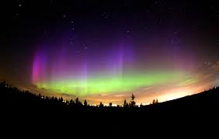

Background

I've only seen northern lights (nls) mostly in Kincardine, Ontario, Canada- where I grew up. Perhaps it can be said that the lights coincided with the local large employers' 'accidental' spills from the nuclear plant.
Greenpeace may not care to chronicle hazards of industry in Canada, within Canada. G-peas put their Liverpool placards in England, but they know politics in North Am don't allow for truth, even of 9/11. So they aren’t to blame for silence either.
I've suggested to the Lodge owner that negligence on the part of the seller was forgetting to record and classify radiation levels here. There is a breed that knows glacier cracking on snowmobiles, so a bit of danger isn't unfair. It is good to question if Farley Mowat’s "People of the Deer" noticed the danger. I haven't read his book yet on the Inland Inuit of the area and their ancestry, history of relocation to Arviat from Ennedai Lake (E Lake).
http://www.goodreads.com/book/show/72530.People_Of_The_Deer
When the nuclear industry removes welfare from the Wollaston Band Indians protesting uranium extraction (72 mining sites in the north, 35 currently active), you know a 'silencing' is occurring. Good reporting is supposed to follow where the silence is, whether it is Catholic boarding school or government out of court settlements for Vatican cruelties.
That's how I recognized the nls, as a product of uranium. Maybe there are more minerals involved, but I know no other with a radioactive element that can reveal orange glowing to a later flat red beyond uranium or what I think it can do. Maybe there are other minerals also in the hydrology cycle of the Ice Lights, but I’ve no experience with other types that were either benign or radioactive. Yellowknife exhibits both green and red lights. Watson Lake exhibits both green and blue lights. Sudbury, downwind of Elliot Lake, exhibits green lights, uranium. Yellowknife gold production may involve mercury, a red perhaps. I’m unsure what else red could be. Watson Lake has cobalt, blue, nearby.
My career path personality testing states I am a driver/ social worker/ cop type. In north Am, there are no cops. It’s a big lie. Social workers work over the non-Catholic and the non-raped. Drivers don't discuss aliens because they are. ‘THERApist’ can spell out as The Rapist, or so. Guess I never learned that trade, or how not to be poor. Who doesn’t envy the wages of a government worker?
http://www.whale.to/v/mendelsohn.html
When in grade ten science, the learning of how Mr. Fennie's teaching of location versus knowing of Rutherford's atomic analysis is revealing, if you know it’s there, it ain't or if you can define it, it ain't .
What's being defined is often mumbo- jumboed with observer/observer circumstances. When perception is clear enough to make pure observations, purer science occurs. In fasting, the ego is removed/ lessened/ out of the way. The bulk of this book was written after or during an eleven day fasting on orange juice, tomato juice, V-8 veggie juice and also tomato sauce. Since then I have lessened my withholding of insights and revelations.
I repeat- good science is done while fasting. As such, the Ramadan periods of Muslim activity represent a cultural possibility for clear science, but I’ve read how Egyptians don't eat all day then gorge at night. I've done that working 16 hour days in my youth before, falling asleep while saving for school during the day if I at while working. It's not healthy, but pure science observation is fasting observation. The observer is the observed; the perceiver is the perceived sort of thing. 'Hold fast, steadfast, and let majesty flourish' is an amalgamation of Scottish clan sayings. For eleven days I fasted, and this book was mostly compiled during the fasting.
There is a breed that has the D-gene. It is a documented phenomenon- the 'Danger'- gene. Some have a penchance for ‘daring- do’ activity, or noble prowess, such as the Monarchs the world over claim the soldiering professions to be (according to the aforementioned prof. Tom of Notre Dame, and of THEGREATCOURSES.com). I'm not saying I cracked glaciers with a snowmobile, but did work with those whom did. Those people belong in the radiation of this Lake, not us cripples.
One such crew of D- gene people was three- two guys and a gal. She and No.1 guy went to the top. No.2 guy stayed at half high camp base, or a base camp below the peak, but not low on the hill. They cracked the glacier, but when picking up the third crowd, found the second snowmobile didn't start. They sandwiched her between them on the running snowmobile and tried to escape the glacier. They failed. She didn't have a scratch. Both guys broke a lot of their bones, or like, all of them. I'm not immune to reveling in a place of danger at times, even if it means going out to face what I thought was solid light acting as a laser on E- Lake later in the story. They would always remember me as being vaporized for science, and being cremated, the risk of being revived was removed. Vaporized means freedom from reincarnation or cloning. Later in the book you'll read of this event.
Just to give an idea of where Ennedai Lake is, just imagine north of Manitoba, east of North West Territories. The Stoney Mountain name itself isn’t in white people vocabulary, but it is at the base or within these hills. This unrecognized chain of hills runs almost from Coppermine to Churchill, or whatever their names are now. These mountains are about 2000 feet at the highest. You see, not only is northern science vastly different, but few live in the north to know what is actually ‘up there’. The end of the book is all nice colour maps for you! You can’t get lost.
I was in the 8th wonder of the world, away from southern comforts, or southern knowin’. Call me a ‘Chillbilly’, ‘cause the mountains were cold. Reading Chuck Yeager’s life biography while being ‘up there’ let me know what a real’ hillbilly’ he was. Ol’ Chuckabilly himself actually has 10/10 vision!
The nls are not space radiation, or not entirely, as when considering eggs- fried, poached, scrambled, sautéed, or you name it. The nls are as fog on an ocean.So why question the nls science? (remove your socks before they are knocked off).
What if the sun is made of water?
Why question southern science? What if Sundogs in collapsed, natural hemispheres can cut into ice as if a laser? Why question the nuclear industry? France did and has miniaturized the reactors. Also, answering questions with questions reveals the industry hides health effects of lung cancer at refining facilities (Port Colbourne in south Ontario, I think). How do of Ontario’s Elliot Lake region affect us? Why can’t we question an industry without threats by the sector? Is it that concerned that Serpent River residents, and Pangnurtung residents of the north will expose something hat nuclear doesn’t want to deal with? My opinion is that the evil of the Russian communism is more important to resist than questioning the sector, by why not do both? Silence is meant to be golden. Often it is cruel, homosexual, cold, and both ignorant and failing a better future vision.

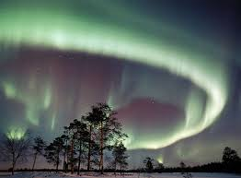

Dedications

The Indian Bands around Lake Athabasca are combining under the name ‘Dene’. Perhaps this is an easier word for whites to work with than Chipewyan. Northern Saskatchewan is, according to the Saskatchewan Ministry of Natural Resources, a huge uranium field that ranges the Canadian Shield formation from east of Fort McMurray area to below Reindeer Lake on the Manitoba border. This uranium field is mostly north of La Ronge in Sask. Province, but encompasses Cree and Wollaston Lake.
This is a book for Lynn Andrews, perhaps getting her out of my system, to survive. Few people travel north for a place to live. Isolation, work, costs, and education prospects are factors that leave the area depopulated. The Russians themselves call the cold a name of ‘General Winter’ as it kills everything. It is extremely cold in the north, and Vodka is the bravery. Lynn needs to relocate her people. I’ve been curious about this area a long time. Such is the power of Lynn, and Ruby, and Agnes.
I suppose this book is dedicated to the end of the northern light mystery, because I think the locals have opted for jobs now instead of protests. Such is survival.

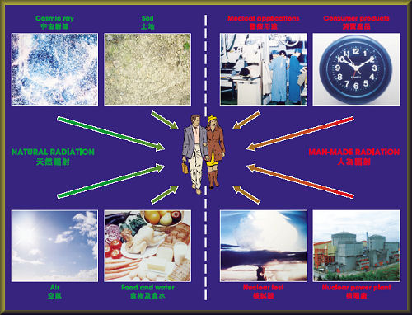

Luke’s Observations of the Northern Lights

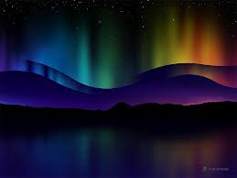

CHAPTER ONE:

A Maverick book

First, a brief outline of conditions and intrigue
During the first two months of my northern stay, I would understand very well how the English sailors would have mutinied against Henry Hudson’s exploration of his namesake Bay. In my opinion, cold makes hatred. I learned to hate the earth only in Saskatchewan’s winter, and don’t usually. In my opinion, Canada and Russia both will always have hatred inspired from the damn cold. In my opinion, the brain goes into a survival reflex mode below +10 Celsius, and sedates after +30 Celsius, or so.
Due to gold in both the coastal area of Ranklin Inlet, NT and also farther away in Yellowknife, NWT, I would attribute low populations of people in Hudson Bay to technology. Not a lack of, but a progression. This may sound funny, but better tech from wood sailboats to steel and ironclads may have doomed exploration in the Bay area. Steel gets very cold while wood is a natural building material for the land of the north if not the waters.
So maybe the gold was found in Yellowknife before Ranklin Inlet. Pirate behavior aside, perhaps the settlers even found more gold in Yellowknife amoung natives, as the Spaniards did in Mexico.
Steel, glass, and plastic all start to emanate…yes, they exude the cold itself at about minus 20 degrees Celsius, so few southerners really know the value of wood in the cold. Wooden boats were probably warmer. No one risked sticking their tongue onto a piece of wood as if it was frozen steel on the playground when kids took recess. But everyone was laughing when we all stuck on the steel.
Northern Lights focus on about 5 precepts:
- Rivers- in – the- sky (hyphenated to sound as only those words can).

- Atmospheres as balloons (there are 7 of them, stacked as pancakes upon each other).

- Ice Lenses (how ice shears in the floating surfaces of water…and in the air of my biome).

- Tesla’s invention of harnessing the ‘balloon’ static electricity friction generated between the 7 atmospheres (I do not know which level he tapped, but probably his device allowed for high variances).

- The concept of root-cellar water barrels as a form of contained water storage and water state change when freezing. My hydrology cycle just simply had an open air concept, above my head.
Having stated the main five points, the following is an expansion of the fifth and last point:
When it was -35 C, the water mist of nls would turn into an iceberg form, falling almost on my head, and would have if I dared to walk into it. Who the hell would walk into an iceberg in the sky that seems to be falling out of the sky into you? I kept backing off, eventually scared shitless and went inside (real brave) and slept.
You may think my response was perhaps unusual at 1 am or so in the morning while I logged trees by the moonlight so the foxes or other predators wouldn’t lurk in them. The moon was actually that bright up there! I learned in tornado weather of the south Saskatchewan hills- Missouri Coteau- that after a day of work, looking outside and seeing a tornado is simply something that will happen if it is going to happen, and I’d be back to sleep before the Big Muddy could send its’ wrath north to Ceylon then down crashing over my home in nearby Radville. This area has the highest recorded hourly rainfall of any place in Canada- a flash flood microclimate of Brooking, a few minutes north. I am actually used to nature deciding my fate.
Then of course was the glowing orange the day after that melted my brain… or felt like it. I’d go inside and cry for no reason (lots of fun). The red ground for a few days after the killer orange didn’t seem as dangerous, but I really had no idea what I was looking at. Ever get befuddled? Minus 35 was closer to -100 as the next atmosphere is said to be, so maybe that is why the ice was ice, not mist. Also, I was not outside each and every night, so how much did I miss? The snow was often an orange dirty colour on its’ surface that industry could dismiss as mining effluent or something floating in. My opinion is daily lights mean daily radiation. Imagine, not being diagnosed with cancer, but getting the leukemia treatment. I have to also question why the E- Lake snow ‘chlorine’ tasting is occurring. Is chlorine a green colour? Is it radioactive?
So suspend your understanding for a time.
The whole concept of an ‘ozone hole’ expects the north to be as if it is a warm atmosphere of southern gaseous filled balloon. My idea of atmospheres is to be understood as being ‘balloons’. I’m not saying I am right, only following other data that others have detailed (Whitley Strieber and Art Bell in the book ‘The Coming Global Superstorm’).
http://www.aidecworld.com/environment/ozone-hole-theory-is-it-a-hoax/
Keep in mind that the following observations were written at the request of Aziz Heraj, and this book ought to flatter him for his benevolence. Often in seeking truth, there is many mistakes, side tracks, blank areas of knowledge, and reversals. It is as if making a Martha Stewart fine dining recipe on occasion.
I’m not claiming to be an authority, on the lights. I am claiming I think I figured them out, just as did Galileo and Copernicus also offend modern science’s perfumed world of expectations.
This is a maverick book, also designed to entertain and maintain your interest when you read. I’ve tried to avoid the Hollywood blatant historical lies for truth however. Also, why should people suffer when being entertained?
The following observations have eventually taken on a form of time/ temp/ wind or a similar sequence. In addition to all the concepts bundling to form this somewhat new science, there is a geological fault line running from the Canadian Shield in Saskatchewan to the North West Territories, in the north east corner of Sask. and the east of NWT that adds to a mystery about the nls. Do Icelandic geological gases have any influence upon nls? I haven’t found an answer to this but I can hypothesis there may be a geo-factor I cannot fathom. What if an earthquake occurs in an area with a lot of uranium? Does an explosion occur that is different from LA’s cracking city line?
I’ll try to include maps at the end of the book so the area is clearer, and if you are like me, you’ll probably glance at the back and dog ear that page for better understanding. Good maps make a book. The quake line in Sk. Runs the south end of Reindeer Lake to Wollaston, to what I think is called black Lake. This line continues north but I have incomplete data on its occurrence in NWT as it continues north. I will guess the Stoney Mountains halt its northern path, but I will not presume, as this book already postulates to turn science into icebergs floating in the sky. In choosing my battles, I have. So does a quake in uranium laden grounds produce a Northern Light?
Variables in in my observations include times, daily occurrences of lights, my physical condition (sometimes cutting wood took my back out), the day’s workload, and probably more than …oh….one more I’ll mention. My vitamin C source had aspartame. This makes me feel as if my brain is mush. Maybe I’m sensitive. So I kicked the vitamin C aspartame tablets for vitamin C contained in jarred jam.
Some days I ate an entire jar of jam, but only after warming it to liquid and having a nice …oh I forget the word for it. But it was a nice warm fruit dish. Yum, and yum, and yum… but the jam was always way too sweet. Brain damage from Aspartame or sweet fruit…orange jam, strawberry, raspberry… I haven’t eaten jam as such since Mom’ used to make it when I was an indulgent kid. Way too much jam and bread really ruins enjoying the company of young girl friends visiting. Warmed fruit is almost as good as steamed fruit.
Splendida, Equal, to me it is as if comparing the aspirin, ibuprofen, valium family. It is all just a similar experience. I use Devil’s Claw herbal pain relief when possible. It sedates the brain, but doesn’t coat or kill the nerves.
I had valium when being given an angiogram at Calgary foothills Hospital. Mostly vegan, the docs said I had some of the cleanest veins going. I am a fish nut. So my brain might have been on the sugar at many times when recording the following time/ temp/ wind data. The jam session occurred later in my five month stay. I’m on the computer writing this so can’t recall the name of ‘warm fruit’ as a dish, being whipped out as usual by the comp screen. I haven’t owned a TV for about ten years now due to this effect. I’m an E-free type of person. Hate that…can’t recall effectively while working on-screen…
If you want robotical data I have tried, but it is more as if the following recordings are at convenience, and not at all scientific. This has been an undertaking that has taken me by surprise, but since I was alone with 7 foxes, there were no conversations on how recordings could be improved immediately. So what if the sun is made of radioactive water? So what if the ongoing northern light of the sun flares only at its round outer surface? So what if Saturn’s rings are effluent from Saturn? So what if the earth’s moon is a collection of vented gases from the earth that forms a ball and not a ring? So what if the asteroid belt between Mars and Jupiter is a ring around the sun, as if the earth were a moon of Saturn? The proverb is… “A great mind echoes thoughts as a cave echoes sound”. When none else are around, the echoes linger. ECHO…
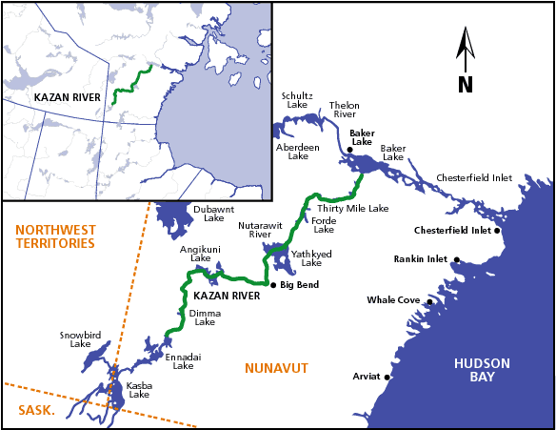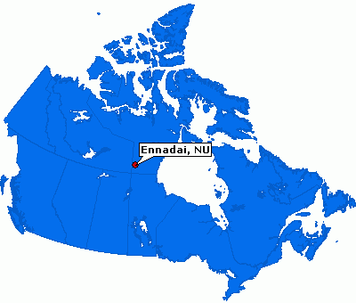

Luke’s Observations of the Northern Lights

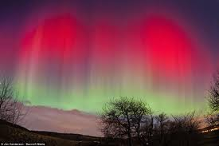

CHAPTER TWO:

What if H2O is mixed with radioactivity?

Tuesday, February 10th, 2013
South Camp Inn’s owner, Aziz Heraj, has asked me to record northern light activity (root cellar h2o energy conversion). Az’s mother-in-law has passed over. I am trying to fathom how to tell him my discoveries without offending his/Inuit traditional views of northern lights without being the souls of the dead.
Northern Lights (nls) activity is again consistent tonight. A high dome defines nls produced by the heat rising from the backside or north side of ‘north bay islands’ and their shallow and sheltered heat production. The dome has arced from the north of the bay towards the south end again, consistently lighting ice lens activity in the air until vapour drips as burnt out ice dross. Consistent heat vapour activity cases gas to solid or gas to liquid then solid.
Green mist is mostly going through yellow liquid state very fast at flare up stage. Flare ups last a short time- less than a minute. The entire arc in the sky flares then proceeds to move ‘the dome appearance of’ nls as a unit into another water vapour sky ice lens area.
Strong wind tonight, from Coppermine (Kug) direction (north northwest) that pushes out nls into a band arc, extending the dome into a crescent shape The moon hasn’t yet occurred on the horizon at 4 am, but I’ll bet it’ll be good when it does appear…It is a clear sky night. (I thought the moon was Venus for a while due to the colouring in my atmosphere- I’ve never met a moon quite like at Ennedai Lake before.).
I’m going to recommend more …(illegible.)… be dropped off here and find out if the fax is okay to send/ use to develop a nls audience…be dropped off here and find out if the fax is okay …

Feb 10th/ 2013 4:30 am (Writing is terrible due to back injury.)
The arc dome across nls islands has blown the peninsula and split into the lights over the back marsh and Ennedai Lake coastal area. The lodge peninsula has broken up the steady sky lens area into two distinct areas. If I had a small laptop I could fax this info daily into scientists.
Area at back of marsh is next to airstrip and almost a round area of light activity and dross blow off. Area above Ennedai Lake usually doesn’t last long on the other side of ‘blue sky bay’. What I first thought was Venus has yet to crackle its flarings of orange and red across the E Lake and above the south mountain hill range area of about 1400 feet above sea level. Hot magma!
What does Ennedai mean? I predict this place as a hotspot for science to study nls. I’m guessing the nls activity is less in the summer. The atmosphere above the living ground level atmosphere is -100 C Atmospheres however occur different here than down south where that -100 reading was taken. The way I was told was that the atmospheres alternate between hot and cold levels. I don’t recall why.

Tues Feb 10/ 2013 5am
Nls Islands and Blue sky bay arc of light has been directly overhead and dissipated from sharp lights to a white cloudy mist, but activity in the marsh area off blue sky bay continues to flare. Sky (…illegible…) one has reconnected after separating between the marsh area and Ennedai Lake. (…illegible becomes legible after consideration).
Temp is -20 C from – 10 C and may affect flaring of lights A separate pod of the airstrip marsh light has ceased. It is all one misty area overhead directly from the cabin. I haven’t had I haven’t had the dross drop on me yet tonight – flare off ice crystal dross.
Separate pod of the airstrip marsh lights have ceased. It is all one area misty directly overhead of the cabin I think a separate winter dwelling may be made inside the main lodge. A simple room above eating/ lounge areas with own cook stove and staircase to encompass both of the two triangle windows. A small vent window similar to the 1 by 2 or so bunkhouse windows should be put in that 10 by 20 or so room to allow air and the room should be fully insulated with a wooden, not COLD steel door.
Az’s Ma-In- Law died. I’d talk biz with him more, but must be careful. This northern lights activity may not be good for his family at the moment although it is a very precise science. Will Inuit “souls of the dead” concept of the nls silence me?
5 am and still no moon crackling over the horizon. Darn! What a light show it is- all orange and red!
A small map of Lake Ennedai area
An unusual formation called ‘eskers’ makes small hill ridges along the north shore of the southern part of the lake. I say the lake is a ‘moose shape without legs’. I lived near its tailbone.
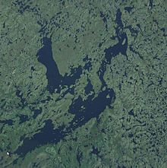
Mostly I lived and dwelled at the cabin in the lodge site. My back injury and re-cracking of fusing bone kept me from an adventurous youthful tour of the area I only imagine from the maps. I have one hour of walking in the snow before I am in trouble. I am very much ‘home stayed’.
Feb 10th / 2013- As requested this booklet of observations has been compiled. Four or five pages of notes start an outline of a new science for myself and probably for others.
This is a typical night here, so I’ve outlined it but may reference others to this date (notes were often incoherent when returning south and deciphering them).
The nls Islands (on map) may represent an area of a crack in the earth mantle, but more probable is simply a series of small islands and shallow pond areas. If there is geothermal, or hot springs activity nearby it would be a wonderful thing. I’d guess due to independent flaring around the east end of long nls Island (Almost Island) and due to independent flare-up of the airstrip marsh area, these 2 areas would be ‘choice’ spots for hot spring locations. The hot springs would explain the rising of the green mist into the air and then how it floats across the frozen biome.
I’ve not heard the ice lenses moving in the sky due to high blowing winds in the tree tops, but when it occurs, it sounds very similar to ice on the Lake Ennedai that simply crunches and changes.
You whom read this may consider it fantasy, so go to Ennedai Lake or webcam it. Go outside, start at 10 or 12 or 2 am. Go inside as needed and get warm, then back out again. E Lake is the 8th wonder of the world, or at least the nls are. You want to disprove me?
www.basecampinn.com
This website can enquire of the owner, at it is the owner’s website; contact him to inquire about a webcam installation or visiting the lodge when it is cold enough, as in late fall, winter or early spring. Technically, I think the NT government owns the site, and it is leased.
7:30 am – no moon making its Muslim morning star.
8:30 am- No moon spewing magma light on the horizon (as seen with binoculars).
Think Ice lenses, rivers- in – the – sky, root cellars, 1000foot biome atmosphere, nuclear fallout, ‘cause it is of course winter.
Feb 10th 5 am- Still ice lenses in the sky, flaring after the initial broad and moving sky dome arcs out to the cabin area from nls Island area.
Similar to looking into translucent ice on the Lake, the ice lens activity in the sky is simply science of ice of ice lenses, air rivers, and water barrels in root cellars that freeze to give off energy heat and contradict the liquid to solid freeze- up of cellar veges and fruit.
I’m a farmer. I’ve spent 5 five years seeking my land in Weyburn, Sk. Province and also the Yorkton area of Sk. I’ve hunkered down in tornado weather of the Big Muddy and I’ve thought of windmill farms in the Big Quill Lake area. Mom probably thinks this is all pearls to swine, and maybe she’s right.
No burn off / dross has fallen on my head tonight. A few nights ago, it was dropping very heavily in the main lodge area, 500 feet away.
Wed Feb 11/ 2013 “atmosphere floating lights” similar to pollution of large cities.
1 am- no nls- misty, cloudy -20 C too cold?
2 am- no nls- -20 C is it too cold? Some mist vapour.
3 am- no nls- fog haze over entire bay/ e lake area the nls usually occur in.
TASTE- strong chlorine taste in snow melted from beneath Ice Light activity. . Is this CL2 from NWT mining activity? Blowing over? Is this CL2 from flare activity? Is there other radioactive rock in the area?
SOUND- similar to walking in snow, but (…illegible…) sound of ice on Lake E wincing and moving. On a heavy nls night I can hear the nls as they move their icy display. It is very similar to a texture of a whale sound, but in this case, more like the grandeur of a waterfall. Ice lens shifting in the sky is very unique. I can only think of an old star trek movie with Spock and Bones and Kirk in cosmic lights screeching as loud as fingernails down a chalkboard. Very, very bewildering those nls.
Hypothesis- Nls occur in atmosphere, heights are different here where people think the ozone layer exists. Atmosphere collapse in the north due to less heat on the ground. Or at least the ground level atmosphere is perhaps only 2000 feet high. I watched the light level and cloud level and compare them from 1400 foot high hills across Lake E. My theory is:
Lights float on the first atmosphere.
To make sound, ice needs to grate against itself but because height levels seem to have a common lower level altitude, I’d say the gas- ice- liquid- energy thing occurs at a cross of atmosphere e.g.) my atmosphere at -20 C and the next one is at -100 C or – 90 C. A duel friction of ice lenses and atmosphere ‘flooding’
Ice floats on water- water lights float on heated atmospheres or I may be wrong or inaccurate. Sounds may only occur during flare- up.
4 am temp – 25 C no nls
5 am temp? (Groggy & sleepy) no nls
6 am -20 C no nls, very cloudy
7 am – 20 C no nls, barely sunrise due to clouds.
Thurs Feb 12 /2013
1 am- few lights- only a pool opening to the north- a hazy and cold night temp is – 25 C.
2 am temp -25 C- mist in an arc overhead, no nls, too cold?
3 am- temp -25 C some mist in a horizon arc.
4 am temp -25 C finally! Green lights from the airstrip marsh tis below that green mist and the green extends to the circular pond height, perhaps to the pond far to the west also. South E Lake is a lightshow. A laser hologram concert show, but not much flare off of yellow ignition just mostly green.
6 am- temp- 25 C –green mist where morning clouds always are- around the Lake- lights are water!
7 am temp -25 C – sky is going to sun, but green mist above blue sky bay still exists. Most light show is ended.
Are hot springs or geothermal vents causing the lights? Is sheltered H2O warm enough? Are any hot springs in this area? It’d be ‘geothermal vs. solar” if hot springs are here.
(last comment perhaps isn’t coherent- must be that daily vitamin C jam or just another exhausting night trying to understand why democracy can’t be as it was in Greece, and have a Corfu massacre.)Radiation itself is a ‘hot’ thing. Is radiation itself causing a temperature differential to make the gases rise?
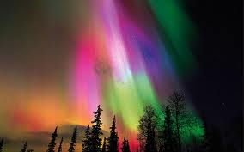

Friday Feb 12- exhausted
Sat Feb 13 – 3 am- no nls, only mist I’m betting the other side of the water will generate nls. One misty arc of cloud above head at this cabin from the airstrip marsh to E- Lake shoreline.
Sat Feb 13- 4am- no nls and very cold wind from Hudson Bay direction.
5 am- 20 C no nls- very windy and dark
6 am- nuthin’- but wind
7 am- only wind. Therefore, wind removes nls (they aren’t mountains).
Sun Feb 14 5 am- sparse lights, no icebergs in the sky
6 am- dimmed or faded lights
7 am- lights, sparse.
Mon Feb 15- exhausted
Tues Feb 16- exhausted
Wed Feb 17- -some lights over airstrip marsh pond way far out, not next to it. Okay, so I think nls are H2O mixed with radioactivity? I’ll repeat that:
What if H2O is mixed with radioactivity?
As I write this out in its’ first draft, there are many spelling errors I could have avoided and syntax improved. This nls experience has caught me unprepared. I was under the impression of my work here being mostly of a custodial nature, not pure science.
Thurs 18th -20C nls across lake in between hill points, at 12 thirty or so am.
Are both H2O mist and nls radioactive?
I’m remembering before I started to record this nls account, about Feb 1st, when there was brief sounds of waves and actual open water in the middle, or towards the hillside of lake E. It is a mistake to trust that water. It sounded as though a whale was coursing through.
Do nls occur regularly at sites of high radioactive rock? This lodge could become a place for mining, a base camp. Aziz could sell to a uranium mining co. (After returning south, and in talking to a resident of the Sudbury area that confirmed nls activity. Prevailing winds from Elliot Lake to the West could be their source- a well-known mining area for uranium). We are not alone. Tom wrote a book:
http://tomzoellner.com/books/uranium/uranium-excerpt/
Thurs 18 (21?) 4 am- 20 C clear night, little wind, luminescence over airstrip marsh area, but not nls. Is that uranium? North Sk. province has tons of Uranium- Wollaston Lake, and also in the Cree and Athabasca lakes area.
If owner Az sold to a uranium company he would make a profit. Birch bay- airstrip marsh luminescence (birch bay is due south the cabin by about a few kilometers).
Fri 19(22?) I’m losing time without an engaging economy here.
12 am -15 C some cloud, and slight nls. Maybe H2oin the clouds isn’t H2O in the nls. Very similar arc of mist, nls has shown itself above lodge area on its nightly trek south to above this cabin. Only flaring yellow above E- Lake, green/ H2O mist the rest of the arc length from airstrip marsh to over E- Lake. Seems green mist glow over hills across the Lake, but very slight.
5am -15 C Mist arced the sky in various lens arcs from origin across bay and inside “almost island” or nls. Islands… slight green mist look, but mostly looks as if H2o vapour.
6 am -15 C Mist is a plume pattern from far east end of ‘almost island’ to above my cabin located head. Flume is misty. Location of misty Location of misty flume is similar to phenomena of a single white clouded thin line “jet stream” cloud seen yesterday during the afternoon- around 4 – 7 pm. Flare is almost straight up from east ‘almost island’ to the cabin, but veers towards the airstrip at its end.
7 am -20 C Small map depicting two crucial areas to understand this nls activity- the XGUN and the XPOND, both ‘hotspots’
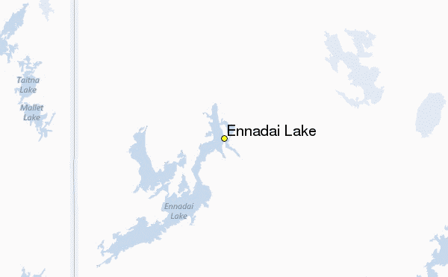
I lived right near the very bottom left of the lake. ‘Blue sky bay’ (bsb) is on the lower part of the legless ‘moose back’. Imagine three bugs on the back of the moose- bsb is the middle one. This computer won’t let me use paintbrush to show any more.
Lines of green mist rising from XGUN site. XGUN and XPOND are approximate locations on a small map above. Just looking at the XWORDS makes me think of serious Patrick Stewart movies.
Flare site XGUN nls shoot outward and upwards from XGUN. Lines, rigidly straight (unusual occurrence in nature) about 500 feet in length, they form as light, a slight curve from XGUN to the lodge and over the cabin eventually as if a crack in the biome ice.
XPOND site flares consist of dual streamers, the one leading over the lodge becomes yellow flared then disappears, in its ‘poker hand-like’ crystalline form. Second XPOND streamer extends more south over airstrip marsh pond.

Luke’s Observations of the Northern Lights

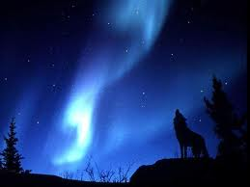

CHAPTER THREE:

Canada really is ‘Bloody Canada’ as was ‘little France’, aka ‘Bloody Scotland’.

Or:

So I think URANIUM is in the hydrology cycle.

Fri 19 (22?) -20 C Too tired to correlate temp and nls frequency. 8 am
Wind may be a factor, but nls flared only after -15 C became -20 C in the early morning. The ‘hill- chill’ effort bringing colder mountain air may indeed be a -5 C sufficient to heat both uranium and water into nls activity.
Not a fallout morning.
Mostly green mist layering activity not like the icebergs grating atop the 1000 foot atmosphere/ biome of two weeks ago. I couldn’t hear the slight yellow flare off this morning, nor could I see the dross/ radioactive fallout.
8:40 am sunrise
Not a heavy flare night so I didn’t expect to see red/ orange fallout on the snow, as I did a few weeks ago. It was scary, and it took these three weeks to understand the fox dens were in an area I saw both red and orange- radioactive/ radiation colours.
My real brother, not the rude asshole that plays dumb cause he’s my Dad’s new family, told me that iodine in salt would counter radioactivity. A religious cult leader of my impressionable youth also stated that Chernobyl survivors had a lot of honey products. I think other factors might have been at hand, but bee pollen is on of humanity’s few ambrosias. Bro Mart and I grew up next to a nuclear power plant, so my salt intake, contrary to popular health fads, is something ramped up in this environment. It does however, hurt my head to have more salt.
Sat 20(23?) -20 C / 5 am a fog day
Low visibility, about 10 km, but low ceiling…therefore high fog= no nls. But I am definitely wrong about one thing, I’ve been looking outside from inside and through clear plastic. There is actual snow outside, not fog in my weather protected windows.
Sun Feb 24th -15 C 3 am no nls but fog/snow
5 am no wind, no nls, but bright moon. Moon vs. nls?
If photon activity in this weak atmosphere biome is normal, moonlight photons with an ever-present halo may prevent nls. The sun in the morning is often accompanied by snowdogs, so why not have moondogs?
Mon 25th no nls
Tues 26th 2 am very faint activity mostly a (…illegible…) phenomena… rounded, not lines? Mostly ‘will-o-wisp’ over small pond areas.
3 am some ribbons over E Lake
4 am continual slight ribboning over E Lake ribboning is green mist not heavy yellow flaring.
6 am green ribbons
Perhaps the cold of -20 to -40 opens cracks in porous rock that helps the chalky uranium escape as vapour to the atmosphere. I may be wrong, but I am curious if nls occur in warm weather of June- Aug (They don’t I think, even the spring relief crew arrived and acted as if I was crazy @ - 5 C cause they weren’t showing up. What an act these lights are. Only for the frozen… I’d usually wait til I was very cold while observing before going inside to the fireplace.).
Wed Feb 27th 1 am/ -25 C
Cold= nls
Lots of broad bundled ribboning travelling back and forth above my head and north across bay and back again. Slight ‘sheet lightening’ effect usually occurs in the sky on full activity nights. Emanations seems to have a focal point beyond airstrip marsh- perhaps the small pond over in that area.

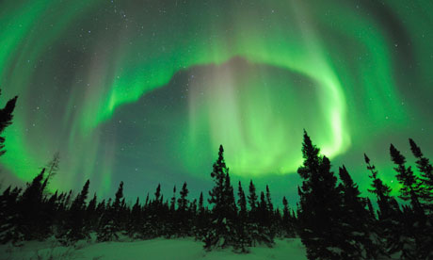

Wed Feb 27th/ 2013 1 am/ -25 C/ COLD= nls
Lots of broad banded ribboning travelling back and forth above my head and north across the Bay and back again. Emanations seem to have a focal point beyond airstrip marsh- perhaps originating in the small pond beside the area. (Think ‘upside- down party streamers’.) I’d be on a good 2- hour walk at my pace one way to find this exact area, so although it may be a nice welcoming hot- spring, I’ve also heard wolves in that direction. You can imagine all this activity not showing up for the ‘electronic era generation when they show up in the spring warmth..
On the maps the small pond is VERY small round. Does size effect emanation? Would an oval shape produce other types of emanations? Is the pond a Ur (uranium) hot- spring or an H2O hot-spring? ... both? Does the Liard River hot- springs of N. British Colombia also have nls? Lots of green, mostly thick ribboning of green mist. No sound. No thick ice resting on the 1000 foot ceiling of atmosphere above head. Rare yellowish flaring of the green, and no direct fallout tonight.
(more of a scientific date/time/temp being stated…I really wasn’t trained for this, but I am happy to try to improve.)
{unspecified time after 1 am} -25 C nls are very active…it’s just so nice to be below the radiation.
The Ur industry of Port Colbourne’s refinery from Elliot Lake’s serpent river mining has an industry silence on cancers from refining UR and also a politician Romanov’s fixing of Canada’s ur industry pricing to 60$/ ton from the world’s 10$/ ton. I grew up near a nuclear power plant. All are silent on true health effects and politicians are happy to silence all dissent, including info. On Wollaston Lake’s (Sask. Province) people protesting any sickness occurring due to uranium in the H2O. Pangnurtung, NT territory near Iqaluit, also has a history of H2O and UR making people sick. This has occurred in folklore, well before industry even knew of UR.

Wed Feb 27th 2 am – very few nls
3 am – few nls
5 am – nuthin’ and minus 30 C.
I was asked to record what I could of the nls. I haven’t trained as an ‘in-field’ scientist. As such I have allotted liberty to the colloquial ‘nuthin’ appearing in this documentation. This effort is above and beyond the call of duty and the last caretaker preferred hockey games on TV to viewing nls. I’ve been an early morning bird for a number of years. Usually reading in the wee hours I recall my Mom’s windshield being shot-put by a kid paid by the Thompson mafia in Canada. She was driving on a one way section of a three lane highway. My Mom survived my Dad’s ‘silverback’ olde-boy community upon her divorce, simply leaving before he used his social control to hunt her down and make her submit.
People can say what they want about me, even frame me for my brother’s promiscuity and my sister’s exploits in their youth. I was told no- intercourse til marriage, so I obeyed that. My Mom deserved to go to school if she wanted, in or out of marriage, and my Mom’s Dad actually pulled the same thing on Grandma so it isn’t surprising that Mom married her father, love him as she did. Granddad’s passed away now, we all loved him, but Dad still thinks his exaggerated sense of being a communist cheering on Cuba against the USA is good for Canadian business. Canada really is ‘Bloody Canada’ as was little France, aka Scotland. I am unsure which is more pathetic, traditional abuse, or the lack of genuine love in what people claim is a ‘show’.
Perhaps – 20 C to – 30 C or so is a sweet spot for nls activity.
What is – 25 C to – 15 C for UR? Does UR have a – 25 C to – 15 C temp certain cold weather reactions? What is cold fusion- how cold is cold? Most smug south science doesn’t know how cold col -15 C even is. My observances may not be single temperature isolated if I am correct about atmosphere deflation. So get this- it is important that the – 35 C temp in my biome living level is not the, and next to the – 100 C atmosphere. Why? The range of temperature away from the – 100 C range may be the factor in successful lights.
Apply that to cold-fusion science. If the studies are done on layering effects of cold, the energy may be found in the differences, not in the singular temperatures. Put it this way, the heat you can make rubbing hands together in the chill of a cold may be similar to 2 cold hands rubbing together. I am working on intuition here. It seems important. I’ve never heard of multi-layering heat reactions to bake buns in an oven, but Martha Stewart recipes may call for heat and cold differentials. “Blue trout’ is just one such recipe I read in a fishing book. Sautéed in vinegar, ‘blue trout’ is a differential dish. Annealing steel requires multiple applications of heat and hammering, and so there is a case of differentials.
http://www.themarthablog.com/
So you‘ll think I may be off my rocker here, but I know someone will read this and understand how one temperature application isn’t a real world application. In Kung-Fu, one strike is ideal, but multiple strikes and combinations are the norm I think. Bruce perfected the death punch, but he wasn’t alone. Bruce Lee’s ‘one strike’ is survival, but a study of ancient texts shows even energy diagrams the ancients developed to kill a person without knowing, by a strike to the midsection at a proper time that kills a person 2 weeks later.
Martial arts are simply marital arts to improve a relationship. Anyone who remains in the freedom of monogamy knows that being healthy is important beyond traditional obligations of caste and expectation.
There are scientists in Japan that claim water has sentience and have taken molecular photographs to prove that consciousness of water occurs differently. We all think it is H2O, but that is an unfair concept. It is H2O in consciousness, and assumes different forms in its states, so is the northern lights a phenomena in consciousness?
Guess I don’t like Dad trying to submit Mom.
7 am no nls and – 30 C (too cold?) from hills across E- Lake blowing in their cold hill top stone weather. All hill/ mountain areas are colder between 4 am to 8 am due to cold blowing down from top to the bottom.
Thurs Feb 28th/ 2013 – exhausted
No sign of grey single ‘jet stream’ from north area I call XGUN. This seems to be located towards the island cluster between lower and upper E- Lake. Funny talking N- S- E- W. with one of the fly-in spring youth, he would talk magnetic north, but not map north. Between the ‘Almost Island’ and the hut at mid- lake is where this light activity occurs.
Fri March 1st 5:30 am – 6:30 am/ -10 C only no nls, overcast from yesterday’s whiteout. Do nls occur only at – 15 to – 30 C? No nls in today’s cloud, but maybe they are above it all. It is unusual. But perhaps natural to miss a natural world phenomena. I don’t think I ever missed a mountain or a hill before. I’ve missed the Lake I grew up on, but I do miss the lights. They carry a hazard, but also wonderment. Sometimes I don’t like mountains due to the cold they can carry. But the lights perhaps act as if they are indeed alive, dancing or moving in the sky. Maybe it is the illusionary form of inter species relations that makes the water in my body/ consciousness also enjoy the company of the lights. They are water after all.
So the story about Michael De Nostradamus was that he gave a crippled old woman some oil of Antimony one day. He was known as a plague doctor in his day more than a seer. The oil of Antimony turned the woman from cripple to young and supple overnight. So why am I wasting your time? I am not. Read this well oh reader- the oil of Antimony was professed to remove a substance called ‘heavy water’ from the body of the woman. If a secret of immortality is to remove heavy water, than the nuclear industry has an effect of distilling the very substance that causes a body to age. I’m claiming nothing here, just retelling a tale from my years of pouring through books in prairie snowstorms of minus 40 C on the Great Plains where I once lived. Having a home is something very wonderful, even on the edge of what I would call ‘Mongolia’ – a highland area that rolled February weather down upon my little village.
In questioning atmospheric friction igniting yellow in green nls mist there are varied sciences one needs to consider. Tesla towers used electricity, or ‘static’ electricity generated between two layers of atmospheres (or more?) and harnessed it for daily use. Just keep thinking of atmospheres as balloons- remember all those party tricks as a kid that we all played with balloons on the wall, ceiling, dog, and…even the cat with very sharp claws. There is electricity that Tesla has harnessed that perhaps goes relatively unused today. Tesla first is noted doing this in Colorado Springs, and secondly in NY, NY with the backing of a hugely wealthy banker I think was JP Morgan. JP decided after a while that the tower wasn’t a Christian operation, and shut it down. Tesla is a sort of a funny fellow, but I imagine he didn’t have the savvy to market and remain in good grace with the clouts of society, as he was a science sort of fellow in North Am’s grunt thuggery of a prostituted society. It sucks here for people who think.

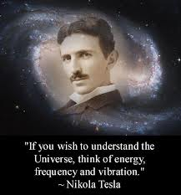
http://www.biography.com/people/nikola-tesla-9504443

Tesla also made Niagara Fall’s first electrical generation station to harness the one flow of electricity, but if you ever read up on Edward Leedskalnin and his ‘Coral Castle’ in Homestead Florida, you’ll hear how he harnessed BOTH currents, not just the positive flow. Tesla intended Niagara’s electricity also to be ‘free’ for the masses. Tesla was picking up voices on his Colorado tower he claimed were originating from Mars. Personally, I think until we can end the ET silence in society, all our good science will remain unused.
Sat March 2nd/ 2013 – 10 C I’ve a mouthful today. I’ve never been on cutting edge or leading science before. Wow.
My reader, let’s recall some neglects of science in both the working world and classrooms. At the moment my authority is survival. To survive, I don’t have to care about limited scientific knowledge. But I have to survive. I am not saying I will shoot icebergs out of the sky, but this radiation environment isn’t one I can leave. And no, I don’t think I will use the Gun on any icebergs. The wolverine itself is majestic, though like a tank. The uranium is not something that a gun can fight, or so I think.
Point one from Tesla’s friction atmospheres: Tesla documented ‘dark light’, invisibility, and time travel. He invented wireless.
Point two is about changeable biosphere/ atmosphere heights. This point is all about H.A.A.R.P. project of the USA testing and using the atmospheres as a communication device for when electronic communications fail. Originally designed for submarine use, HAARP cannot experience blackouts. A wide variety of locations exist for HAARP High Amplitude High frequency Active Aural Research Programme is HAARP, I think Alaska and Puerto Rico are 2 sites for the HAARP testing, but some claim one is in Wyoming. I’m unsure the scope of the full HAARP agenda, but it is new to the culture so there is resistance.
Point three is atmospheric heights and number, with temperature variances. In Whitley Strieber and Art Bell’s ‘The Coming Global Superstorm’ (1999, Pocketbooks, NY, NY) book there are 7 atmospheres listed. Whitley is known for ET research, Art Bell is known for his late night alternative radio show. I’m unconvinced they have a correct book title, but who am I to they giants? The book itself suggests when the temperatures no longer cool off in the ocean that a wider Panama Canal needs to be dug to reset the earth’s cooling effect. The book says the – 100 C atmosphere above the living one is that cold, but doesn’t talk about how the – 55 C in land level at my campsite will interact as opposed to the usual southern comforts.
http://www.amazon.ca/The-Coming-Global-Superstorm-Bell/dp/0743470656
The concept of different levels and temperatures was shown to me once in a freak 10 minute storm that destroyed over half a million dollars’ worth of trusses in a new building. The storm appeared and then went, leaving behind a havoc of power. As lightening balances ions, so too is the theory of temperature balancing. But I think it is a good idea to think of ocean layers when considering sky layers of temperature. Our biome has developed over eons; as cushioning of spacefaring 23, 000 km through the Milky Way velocities of the earth’s orbit around the sun. So bringing together divergent though entails juggling chalky UR in the hydrology cycle, biome height variances, HAARP blasts into the space, collapsing biomes, friction flaring, and perhaps limits and breaking points of atmospheres. Bones break. Nations break, why not the air? Less heat perhaps= less atmosphere inflation. Holding onto those grab-bag of concepts, I will state now an extreme of what I think can be called nls activity, but at ground level.
In viewing the iceberg in the sky phenomena, and its fallout, the icebergs seemed to be descending upon me, but then had the fallout occur, preventing the mass icebergs emerging into my living level of atmosphere height. There was a barrier the ice could not bend into or collapse into. Having said that, maybe conditions exist for such a thing to occur- Giant’s causeway on the island of Manx, in the Irish Sea. A flaring activity that displays ‘Chiclet ‘ size and style fallout would produce at ground level a giant’s causeway.
http://www.causewaycoastandglens.com/Giants-Causeway.T1144.aspx
Imagine a mold for a foundry casting… now imagine the ice incasing the Giant’s causeway and flaring. It is an unusual thing. And yes, it is not the island of MAN, it is the Island of MANX, in proper terms. Many atlases cannot convey accurate politics for many reasons, and the UK doesn’t want any Scandinavian land claims, nor missiles on that island to complicate their lives. Russia has shown it will back Denmark with its claim on Canadian islands in the north. Maybe Russia would back a Swedish or Norway claim on the island of Manx. Or, maybe the locals forgot the real name, it happens in just 3 generations on the Canadian prairies amidst isolation and empire change.
So the balloon atmospheres collapse up north. Put aside the why, and there is a show of what people call the ozone hole. This occurrence may be a natural thing. It may yes be a hole, but then so too might the moon collect the effluent of the earth from that exhaust area…just as Saturn’s effluent is found in its’ rings and the suns’ effluent is found in the asteroid belt.
My dear reader, we cannot judge the science of truth with old eyes, ears, and concepts that are based upon a flat earth concept nor a world that only knows constant warfare of tribes to hell bent to stop and create wealth of both material and intellect.
Two types of nls as yet occur. One is misty green and ignites into a yellow colour. The second is an ice based green that is audibly loud, and floats in the sky… on top of the bio dome.
Mist in the sky and the ice is on the biome, or maybe both in the same place at different temperatures. Tonight is a warm – 10 C . Misty green billows flow as water vapour activity only.
Who knows, maybe even water has another state that it is in besides its’ solid, liquid, gas state taught in grade schools. This place really questions everything. Do liquid lights occur? Or are they only frozen lights? So what if the sun is a form of liquid … or simply radioactive water? It could possibly be only ‘light’ around its’ spherical perimeter which would mean light is water. Tesla states dark light exists, so both dark and light are water. Is the sun a giant northern light? I am not trying to make communism fit the world as the Russian aliens do, I am trying to find truth. If the made of water. What science is truth?
By the way, ever see how science has no consensus about the temperatures of Saturn? Some account a near oven temperature… but only on the dark side, while the lighted side is frozen. Others don’t try to find the truth but repeat tradition. If the Earth effluent falls or is condensed on the moon, then the Saturn must also have some heat to generate the rings of atmosphere effluent.

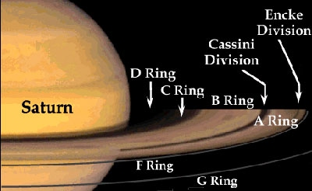

Southern atmosphere diagram vs. Northern atmosphere diagram (where’d it all go?)

In my opinion, the ozone hole is simply a deflated ‘balloon’ atmospheres without air and gases that the southern atmosphere balloons have. On the tree line, there is little air and gases. It is natural.
Traditional people avoid new thought. Vikings failed in Greenland to adapt, and it ended their empire expansion. Historical technology and traditional reluctance won’t test its’ limits to maintain self- awareness I’ve had to survive and to make sense of this circumstance so I do not care about adhering to traditional thought.
So I think URANIUM is in the hydrology cycle.
This morning a south wind blew it all north into a single east west long pillow. Once collected, this pillow flared and was gone. Some nights are very clear and defined- usually the ones I wear my value village 1.50 pair of glasses on. My eyesight is shot at long distance, and when I have glasses, I am a different person. Not being able to see properly is an incredible handicap, one I took 43 years to learn that another way was possible. It was only when my back was gone and the disability support was there for me to actually try glasses. Actually, I was tested for driving a taxi and told I needed glasses.
All the streamers gathered from a single gangly mass to a long pillow, proceeded north and flared to disappear. Is flaring due to wind, friction or a mix of both?
In considering different types of lights and different minerals in the H@@o I am used to green and yellow colours, but there are other light colours out there. So perhaps the sun is a pool of H2O in constant flaring mode.
Okay, so the book has dragged up to the last few pages.
You’ve read and laughed.
But watch the nls.
Night after night, watch them.
Our science isn’t accurate.
The sun is water, maybe radioactive.
Liquid heat. Natural gas.
Science lies to us and the nls reveals the sun is water.
The earth vents dross that collects on the moon, or catches on the moon. The sun vents the asteroid belt. SETI needs to search for ET life within star water proximity. Starwater generates religious cult hatred of truth. I do not think this book will have any immediate concern, beyond the Toronto board of education already hypothesizing this nls truth.
http://www.seti.org/

Luke’s Observations of the Northern Lights

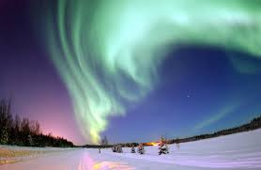

CHAPTER FOUR:

I’m baffled by this all… & older bro says “more iodized salt”.

Sun March 3 (4th?) 2013 only -10 C but if feels like – 30 C from Hudson Bay.
2 am Whole entire mountain across the lake is aglow, in its’ north part, not the south. Wind is fierce, and there is a radioactive glow on the horizon in my opinion. How far to Hudson Bay does this field extend? To Arviat on the Bay’s edge? If so, the account of Farley Mowat’s ‘People of the Deer’ book didn’t help the people avoid the radiation.
When first arriving on the jobsite, I thought I was seeing a radio or commtower across the lake on one of the hills. It was the north hill, and I thought also I was seeing Venus for the first time. The moon crests the radioactive hills and appears to be made of magma itself. Before rising to a certain….approx. 30 degrees on the horizon, above the radiation zone, or so I think.
So what is happening? Is the moonlight sufficient to set aglow a radiation area lacking an atmosphere to protect it from direct moonlight? Is the moon actually spewing magma and science doesn’t report to us that the moon is volcanically active? Is that the real reason the Apollo NASA missions were over and done with? Where’s a good place to land in a volcanic moon?
I really am baffled by this all.
Here above all other information, is more to the mystery. Different sources say the earth is a different shape, no matter how satellites colour the pictures.
http://www.hollow-earth.org/news899_1.html
What if the earth is cylindrical? How about oval? James (Marshall?) Gardner claims his hollow earth theory, and folklore claims people not only living in caves in the earth, but an internal sun. So what do we really know? We cannot even talk about aliens freely. We cannot even talk freely about Vatican abuse. We are silenced in our communities by sex-predators so how can we possibly have accurate science? Does radon glow green? How does Uranium act in an earthquake? Did the Norse people name Greenland for the nls? Who would know?
Sun March 3rd 2013 3:30 am
My older brother says to have more iodized salt. I use milk when too many pesticides occur. The solar panel batteries in this cabin are leaking what I think is sulfur chloride, but may be lead titanium or some other battery compound. I air the place out 2X a day. Imagine, not breathing well inside, but having to air out at – 45 C and not being warm for a few hours while the cabin regains heat lost. It is a workplace; there is no doubt of that. The boss man Az reminds me he has never been to the place but just invested ‘sight unseen’ with photos. Risk taking seems to be good for some people, but I really wish I knew how to risk investments and get out of the rat race instead of radiation, old batteries, broken vertebrates, lack of orange juice and I suppose the list never ends if it starts.
http://www.survival-spot.com/survival-blog/potassium-iodide/

Why does society’s sex-predators get all the housing, all the nice cars, all the wealth just by justifying killing their victims because they always do as homosexuals. Fuck tolerance. Even the economist online magazine wants to pull my comments because I recognize homos abuse children. Always. And they always blame others. Always. We need to protect a human environment, not a cold non-living suck culture. North Am is gone with Obama’s minority whining drug communism. I have tried to leave now many times, I am just so damn poor all the time cause of injuries. And I’m vegetarian also! 10 % minority in a place people are almost forced to eat the meat. Guess I’ll always feel trapped, but my website of helps me keep perspective and that ‘I am more than a physical body.’
www.relax.moonfruit.com
There is severe particulate on the hillside. I may not understand it, but there is severe particulate. Do you know, I have made this place my home? I am thinking that society has 2 years before a solar flare dings it and that I will survive staying north. I want to go back home right now. I don’t want any of this south crap my asshole Father’s politics have forced me into. I just simply want to go home. But this home destroys me. I fight a battle to survive this place I call home. If I am not careful, the sudden scars appearing on my hand from abduction experiences will become greater and I will lose both mind and body in this outpost. Aliens don’t like large human communities and I am unsure I should type this.
5 am – 20 C little wind some green mist flaring
7 am nice lights – 25 C The XGUN site produced a long flat grey line across the sky I didn’t recognize as a crack in a frozen bio dome. I think of my XGUN as a photon weapon or sort of an Old Faithful geyser of energy I haven’t seen before. Imagine, abductions, aliens, green mists every night, no people around, white capped twice as tall as me animated corpses the aliens toy with from other times (do get cremated when you pass over, ok?) and then the next thing and the next thing and the next thing that melts the brain such as battery gas leaking and making the water taste funny, but it is my only drink cause my back is out for another few days in a row while chopping wood so I won’t freeze.
You get the picture. I was fortunate though. Others have been here before me and survived. The stories of the north are of poverty, cannibalism and starvation. Death is a constant. You don’t have anyone nor anything as a backup if doing the job correctly, and I never asked for much help while being there. An older mentor warned me about socializing up north.
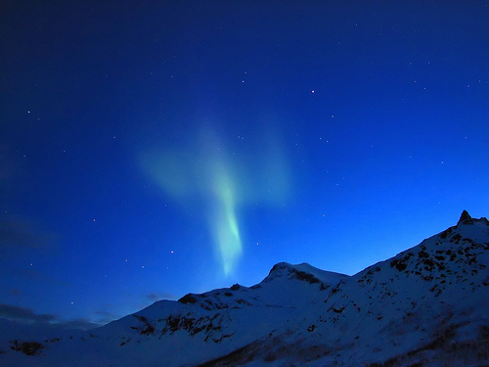
Usually when the XGUN shoots, it occurs in straight lines about 500 meters long, according to the 400 foot rise of land across my lake. But this week the XGUN shot a straight across the bay line. Or was that a crack? Funny how guess work in a new area can drive a person insane. It isn’t just sunrise and sunset here. No this place is ‘rise with solid light sundogs escorting the sun as they ignite uranium on the land nearby because the rainbows of the sundogs are solid due to the cold. I’ve never seen light snowplow an area and I always think I am losing my mind in this place but it is all I have. And then a bird or fox shows up and we make sounds and everything is okay again, amoung the living and previously explained. Being a cripple is a challenge. Being a cripple in a challenge is plain no fun, however wondrous.
I built my tower to survive. I couldn’t walk properly to the distance on the lake before the cell/Globalstar satellite phone batteries would die. The batteries are rated for 3.5 hours when fully charged, but these batteries are almost dead old and done. I am supposed to do this job without proper tools.
So I build the tower on the front porch. It allows me to connect the phone to a power line plugged into the solar array wall socket. I had two phones. The ‘Msat’ phone worked until noon until I read the instructions to open and position it properly. I’m not whining, I simply never used one before. The second phone had these dead batteries. The workplace sends me out here at a cost of 5, 000$ for the plane ride, but cannot replace 150$ worth of dead phone batteries? Egads… I enjoy caring about my world, not sending it off to limbo. The tower protected the cripple from fast moving animals. The wolverine is a tank. I actually think it has a head lock like the caribou do- ever been sighted and charged before?’ Load and lock’’ or ‘lock and load’ is a phrase taken from the dropping of the head of a wildebeest into a ramming and charging position. It is very weird to watch. The head just sort of…drops into place, and then…Charge!
The tower was for security, I could see most the buildings. One time after I had reached a limit, I was well rested and went outside on the usual Saturday night when they were acting up, declared the property to belong to south camp inn, and shot a round into the sky to let them know I was serious. The voice that responded sounded a male voice and when I said “You will leave” the voice said “I am going”. Being exhausted, I went back inside, put the gun down, and waited for the results. Security is a funny thing when a person can’t gauge what the circumstance is. I’m not going to write here what accompanied the voice that said “I am Going” because it is something that will be used against me. Suffice to say, levitation of cubes is Borg behavior in the Star Trek series. And I was alone.
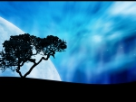
Az was on vacation down south and I was checking in with his kids every week in Iqaluit. I was on my own. Now I am unsure if you have read the accounts of Louis Riel or even lived on the prairies before, but aliens and polygamy pretend we have to treat them as human. Human rights? Mostly aliens trying to belong …and they are aliens pretending to be humans. Southern Ontario has to stop brainwashing its’ citizens to care about a Canada that doesn’t exist. Al Capone himself was a second Lois Riel and if you cannot handle reading these words, I suggest you go back to your place that you hate and think of why you hate your life. I already know you hate me because I am human, not your spitting image.
Asshole polygamists.
The XGUN phenomena has also directed towards Churchill before, not just above my head. For a while I get thinking the Transmission communication tower is freezing in its energy transmissions. Maybe these are bio dome cracks- you ever see one of those biome cracks? Makes a person remember drinking and wanting to enjoy another beer or anything. Consciousness can be aptly challenged, but severe challenges, like ending the Thompson mafia in North America while informing a police gang that wants me to suffer without citizen rights is similar to icebergs on the biome. It can’t be done. The pedophiles in North Am cannot be stopped, only in England, where about 10 other society factors exist can they be stopped. And I can’t explain the northern lights or this area…
Think I should ask for a raise? Richard Kiosaki says not to. He says there is no dead end job and to never ask for one. Maybe he enjoys his wealth so he doesn’t want worker questions for his rich-dad poor-dad offshore worker labour prices.
Imagine being trapped in a nuclear fallout area and a gun likes to go off once and a while. Imagine how I am thinking that I got all the Star Wars tools I need to fight WW3 against the Russians right in my backyard. It was sort of impressive at first, before thinking the XGUN was just plain old cracking.
Mon March 4 / 2013 12 am – 25 C wind from the north, clear sky, very bright lights. XPOND and XGUN formation patterns. Both act as anchors for an arcing across the bay to this cabin.
4 am hill cold descends to push banding back into northern and western lodge area. Tennis in the greens (Mr.Borg and Jimmy C).
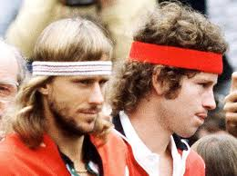

Mon March 4th/ - 30 C / 2 am / little wind
Lights tend to build at XPOND site and behind ‘almost island’ before pushing into the air high enough to crest the top of the biome and travel over it. How does Santa rise up before travelling at velocity? I’ve signed a disclosure with the company so I can be law suited for this book material. At a pay rate of 30$ a day, I wonder how I would pay for a lawsuit.
Ball formation over XPOND.
Progressive arcing from the top of Blue Sky Bay’ to above the cabin and lodge area, these are not space emanations. If I had a proper barium, as in medical tests of the human body, I could trace the barium streaking across the bio dome. Lights rise up, not down, are uniform at the bottom, so I rule out the lights are travelling the underside of the bio dome surface. Think Gordie Howe ever played hockey upside-down? I think my older brother had a few of his cards before they made us all wear helmets. And I think my brother also went to Bobby Oar’s hockey school one summer, at a camp way the fudge up north from where we lived. Things seem larger when you are a kid, but the camp was probably in Orillia, and not way the Nunavut up north.
Sheeting- Thunderstorm activity in the south also produces this whole sky light effect. Will the sky explode on me? Nope, because the sheeting in little bits prevents this. Imagine how southern Ontario’s multiple mini quakes helps prevent a California style ‘big- one’ fatality of fault lines. Sheeting stops any over dose of material building to a critical explosion point. My point is that when the earth had a smaller diameter way, way long ago, the atmosphere may have also worked different. Pangaea as a concept require a smaller earth. The expanded earth explains how Pangaea is possible. So what if the earth is still expanding? Will it get twice as big?
Mon March 4th 4 am/ - 30 C / little wind no nls
6 am no nls
Hillside of the lake is acting like Detroit again- thick red particulate hugging the hills, a black division smog line, and then an absolutely marvelous clear blue sky above the pollution. Few areas in the world have that type of industrial output. Am I seeing a dumping field from Yellowknife or Fort Mac’s oil sand blow over? My cunning intellect says the Inuit are secretly building their military industrial to a point that southern Canada will only realize too late after all the 100, 000 of the north show their power upon the other 36 million Canadians. Quebec might be jealous. A barren land industrial output behavior. Well golly gosh and go figure.
I often think of relating these circumstances to the boss man, Az. I don’t due to + 10 C. + 10 C is when I have noticed human consciousness stops and ‘brute’ survival resumes. Most of Manitoba and Saskatchewan experience this for nine months of the year. This is an area that acts different than Calgary’s blow over from the ocean and from Ontario’s moderate south of England type climate.
I’d say + 10 to + 30 C is humanity’s threshold for intelligence. + 40 C is like walking extreme, but conversation still occurs. That is why Ontario has democracy and the rest of north Canada has dictatorship. Ontario is +10 to + 30 C except for the winter. Funtario!
http://www.summerfunguide.ca/04/festivals_fairs_shows.html
Speaking of brain melting, I was asked to make a record of the northern lights. But before asked to do this written account, I was very active to survive. I would be up in the moonlight clearing bush the originals here also had cleared. There is a demarcation line of old and new growth. I also needed to clear the brush for proper wind ventilation of the outhouse, which reeked. Ever live in the shit smell? It makes a person despair. A person is wary at night in a strange environment, or should I say a ‘new’ environment. There is nothing wrong with calculated danger, even for a cripple. My original words are more suitable for this section, so maybe I’ll simultaneously publish 2 editions.
Tues March 5th – 20 C little wind
12 am banded XPOND to XGUN swathings 3 arcs, separately across the sky)
5 am half snow fall all morning (…illegible…) very dark out, - 20 Wed March 6 12 am – 1 am / - 20 C There are no nls, it’s very dark, and no moon shows.
5 am High raging north wind has developed, Az’s snowstorm from Resolute bay perhaps, but 2 days later. . No nls, thick snow, and chill COLD humidity through clothing.
In viewing weather patterns of this area, spring, summer and fall act similar to Yellowknife, but more as if Lutselke, near Yellowknife. In the winter, this area holes up into a region bordered in the north by Baker Lake and the Thelon River system. This hole is right on the sharp angle that defines a national muskox park and the division of Nunavut and North West Territories. The weather extremely makes a sitting ball on the map that barely gets north into the water again.
http://nunavutparks.ca/english/parks-special-places/index.html
You’d think this place was a valley unto itself, or a sink hole in the winter, just getting colder and colder. It’s the lake ice that does it I think, as many waters are deeply frozen and building on that cold. Many large lakes are in this area. Also, the Stoney Mountains that are not listed in many atlas maps are also a factor. They cut a swath from Churchill to Coppermine, mostly at 2000 feet or less. One side is Mackenzie delta lowlands and the other side is cold, sitting air mass that startles the tree line people up the Thelon from Baker Lake. The tree line is a funny thing here. , but it does its best from Baker Lake going west to NWT. To the south are no trees, nor to the north nor the east. Thelon’s river tree line is a funny thing.
I didn’t tell HQ yet, but orange is the colour of the snow all around the lodge. I try to study the effect and deny it, but IT is there, I just can’t tell if it is dirt blowing in or light dross falling out.
Thurs March 7th 2013/ slight north west wind
Spectacular lightshow overhead, anchoring XPOND without XGUN pivot/ anchoring.
Igniting flare travels from across airstrip to directly over my head and does a coiling thing while twirling in the air. Billowing and twisting at the same time. Quite awesome, but it seems as if some device is also dangling from the UFO above it also.
I’m exhausted, but what a light show.
On the tower that eliminates animal threats for a cripple, the tower also improves phone height and transmissions. Batteries are not meant for this cold, and are dead off a new charge within minutes. Conversations can occur on the tower before I freeze out. One time I called back home and within a minute my jaw was involuntarily shivering, making my speech sound…retarded I suppose. I’m not a politically correct person, nor do I ever intend to be. People should stop spraying 2, 4, d on their crops to get kids that can function without the effects of chromosome damage due to Dad spraying fields to death. I’m an organic farmer if anything.

Thurs March 7th / 2013/ - 35 C / south wind
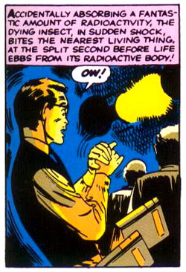
Waitaminute (Spiderman/ Anne Rand inspired lingo). It is – 35 C in March? This month is in like a lion, severely cold as a soviet agent destroying democracy. Leading edge of flaring is at times a reddish white. I thought tonight I would get plastered by dross, but do not. Bit of a fool thing, but cripples do not have mileage in severe cold dark nights. I just stood and watched, worn down by the outhouse, the radiation, the extreme cold, and no orange juice. (pic above is the fateful spider bite that gave Peter Parker his powers. Amazing Fantasy #15, art by Steve Ditko. ..and I am living and breathing radiation…hmmm…what if I got a fox or a wolverine bite? What if those shaman stories are true due to Peter Parker’s shared experience?)
5 am / - 35 C/ south wind Lights are from XPOND and are less active than at 1 am, but stretch from XPOND to mid lake. There’s also another billowous cloud of green mist, similar to my hometown expansive look green mist that I’ve seen being a kid near the Bruce nuclear power station.
I’m wondering if this was a destination spot for the olde people when they travelled to Coppermine (Kug) to obtain copper for tools. I suppose smallpox can almost be as much to blame as any army burning books in libraries. How small are small pox? I’ve worked with milking cows, so have the immunity. That is where the research pointed the cure, in the milk house, but I don’t’ think in the milk. I do think an udder and its’ teats would freeze up here, but maybe some of those Scottish longhair mini cows found on Manitoulin island could survive here. Those Demsters I think they are called are a cow with both hair and fur, down and windbreak hair. Snug as a cow in a paddy.
Or is it a Cow Patty. If you donna patronize me I wonna patronize you but ya gotta let the cow go fellas, it’s just got to be free to run into those barb wire fences…vegetarian perspectives. I also think Fort Mac is a big spill that needs cleaning up.
Thurs March 7th/ 2013 9 am Strong formaldehyde smell inside the cabin, perhaps from old paint, but may be from bioaccumulation in the firewood. Is formaldehyde associated with the smell of nuclear reactions? Is chlorine? Sometimes the lake snow tastes of chlorine. Solar batteries are something else also.

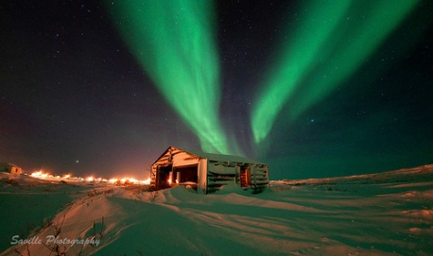

5 am/ - 35 C / south wind
Lights are from XPOND beyond airstrip marsh. Less than 1 am, but stretch from XPOND to mid- E Lake. One long billowous light area south of cabin to ‘Birch Bay’, across 2 point island.
How often did the olde people stop here on their way to traverse the Churchill and Coppermine/Yellowknife route? Snowmobiles and sled- dogs make a practical journey over the ice and snow into something envied by the south that needs to obey road laws.
Wed March 6th(?) 12 am to 1 am / -20 C no nls, very dark, no moon.
5 am High raging north wind, Az’s snowstorm from 2 days later perhaps. He is in Resolute Bay, about 1000 km north and the weather may take a while to get here. Also, this region experiences an extreme cold that sits here, centered almost on Baker Lake, but extends to E- Lake, the north coast, Ranklin and also most of the Muskox sanctuary bordering mid NWT area. That sanctuary follows Baker Lake’s inland Thelon River system to an area that once again experiences the tree line for some really unusual reason. That is why the boundary is there, because the olde Inuit would travel up river to that area for trees. It is probably the only wood source they had without conflicting the Itkillit native tribal territory of the Yellowknife area or more southern areas. Lots of different tribal areas exist in the north- with a minimum of 16 ethno- linguistic divisions.
Farley Mowat ‘Snow Walker’ book of stories on the north recalls tales of the Coppermine area that state the Vikings were in the area, and taught the people there a new version of warfare using crossbow technology previously unknown. Farley’s account entails how there was a lame Viking left behind by his men as he was too crippled to journey home, and also how the bloke had an Inuit family, so stayed. When his son was killed by the Itkillit, he ruthlessly struck back in a massacre remembered in oral history. So the Vikings were in the top of Canada. My theory is they also sailed to the Tlingit peoples on the West because those people had slaves and pit burials for their chiefs- as did the Vikings. I wonder if Vikings got to California and Mexico? Are the White Japanese of Sapporo Island in Japan also of Viking heritage?
So it is 5 am and thick snow from the blizzard that stops even satellite or MSAT phone transmissions to the north. It is very cold and very humid. The Lakes of the Baker Lake region seem to really want to show how Winnipeg or ‘Winterpig’ down south can have competition for the most cold experience a person can handle.
The snow all around the lodge site has an orange tint to it. A dusty orange. I rule out the woodstove itself, having seen ash in the first few days in the area I was told to shovel snow for melting into water. I changed my water site to the lake ice cover, even though it occasionally produced more animal fur in the water than next to the cabin. The animals all trekked in front of the lakeshore going back and forth to their places.
The ‘tank’ wolverine was rarely seen. It has no fear though. I’ve never really seen an animal without fear of people, beyond the look of a grizzly as I rounded the corner of a forestry road in Fernie’s wilderness one day. Those creatures don’t just have no fear, they have a ‘do you mind? I am busy!’ sort of look to their eyes…but that was my only run in and immediate about face run away from a grizzly before. He let me get away. Sheer terror is only experience a few times in life beyond Canada’s constant terrorizing of its citizens into being good catholic perverts like they all are. I don’t agree with this country, and am glad not to belong to it even though it is my citizenship.
So maybe orange snow all around is radiation in the all- around snow.
Thurs March 7th 2013/ slight north wind
Spectacular lights overhead, anchoring on XPOND and XGUN as they pivot the lights and their crossing of the sky.
Igniting flare travels from airstrip to directly over my head and does a coiling thing while twirling in the air, billowing and twisting at the same time. Quite awesome.
I’m exhausted, barely able to rest, but what a light show.
I’ve been asked to record this so I have also built a tower to observe the lights better, without any animals sneaking up behind me intent to rip my throat out- orange pelican did this once, and he is quite a rascal on other occasions, fighting, displacing, bullying, hogging- in the first few weeks I bought them off with bits of food partly out of pity, but never have I seen foxes, and I didn’t want to be their victim. Canes and walking sticks may not work against gang attacks, but foxes seem more solitary than wolves. Red Fisher accounts being chased by two flights of wolves on occasion, across an open lake in Manitoba.
As a TV fishing show host that included many celebrities, Red was saved by the snowmobile fellow that didn’t notice he lost his crew earlier on the ice. I can’t imagine two flights of wolves, three each, fanning out to attack, but both my partial domesticated wolves and the five others seem all too human at times. You see this more also in west Canada than east, easterners until recently would coral and attack in 2’s usually, but the west is moving in here with their big NDP Metis pretending that people that do not grow up in isolation have to tolerate abuse gang behavior.
Ontario’s 10 million may struggle, but in the south we have a human English heritage the west will never know, and never miss. I sometimes imagine the behavior was from settler days when people would disembark into new prairie regions and get fleeced at the terminal of their travels. ‘More people’ prevents lack of policing that continues in western areas to this day. There is no Canada. You are an outsider, even as a Canadian in much of western Canada that desperately justifies evil behavior. It’s very pathetic to live in a country that has so- called citizens that disregard the rule of law as if it were a natural thing to do.

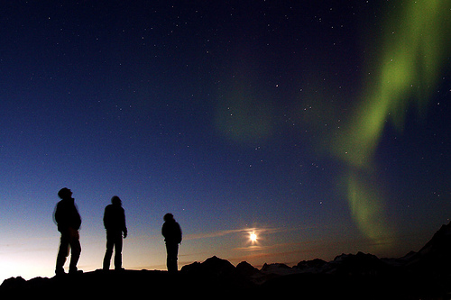

I warned South Camp Inn’s Az that maybe the insanity of the Metis was visiting the Camp on occasion. Some of it turned out to be my pain interfering with consciousness, and the cold limiting my full range of thinking. The tower helps to watch for any foul play- remember, I’m one guy in the absolute isolation. Only criminals would be travelling such a region at this time of year in my own opinion, so that is the job.
The Globalstar phone has old batteries. They are rated for 3.5 hours fully charged, but last ten minutes in the cold. To extend this time, on the tower, I hook up the power to the wall plug in for appliances inside. I run an extension cord out the doors and climb the tower with the power to the phone. This can get me twice the calling power I’ve had before, and on occasions, makes a conversation possible beyond talking about only what is required. The phone also allows my brain to stay warmer in a conversation. South Saskatchewan me that human consciousness occurs at +10 C to about +30 or 35C and that while +40 C is also a part of human range, 10 to 30 is human consciousness. None of those temperatures occur in the prairies for long periods each winter. At this lodge, I take a few breathes of – 40 C and next thing I know I cannot think nor talk as is good for business. It is dangerous to live in cold non-thinking areas.

Luke’s Observations of the Northern Lights

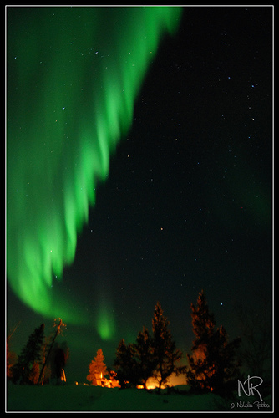

CHAPTER FIVE:

Snow White’s Palace for a Disney destination.

Thurs March 7th 2013 / - 35 C / southwind / 9am
Strong formaldehyde smell in the cabin, probably from olde paint. I’ve moved the cook stove closer to the wall on one side because that wall is an outside cold wall. The stove should be dead center in the cabin, not exposed to direct influence of the cold – this ids due to the wall firebreak that is required, which is stone. When it is cold, that stone requires greater energy to keep warm. The stove needs to be off outside walls that in emergencies will not go cold or retain cold. I almost moved the stove on a pivot of the smoke stack to another in house location, but lacking the fire pad area necessary to deal with sparks that regularly occur, I relent. Also, I consider it a thing that would require permission and I have decided that I have run out of slack in that department, making a few minor adjustments to survive in this cabin, but t not wanting to raise any ire from ‘it has to be that way’ people.
It doesn’t, and Az has told me to do what was necessary before to survive. The last fellow was a bit of a thick skinned perhaps native genotype fellow and I’ve just got my Russian blood to go on here, . Lots of improvements can occur here, but I do mine to survive and wait out the season to see what the back lash for simply surviving will be. Guys coming in don’t know being crippled. I am proud to survive, but one states that he is going to be angry that I am walking with a stick. Another cannot fathom I cannot carry loads. Big macho stuff that one day will also find out.
Mom says society is more and more tolerant to disability. I’m unsure she ever lived the west. In fact, she hasn’t. The Nazi west- Saskatoon in uniforms for Hitler in WW2, and the girls athletic group called ‘swastika’ in Fernie, B.C.…they all are intolerant to work injuries. Even the WCB tries to hunt a person down for applying for status in Regina area, claiming not to be animals and having justified violating human dignity time after time in the western idiot thuggery of Louis Riel’s legacy with Al Capone. Ontario needs to leave north Ontario and Canada to not be abused, but I fear it is too late for our English heritage to maintain its’ non- catholic and non- traditional unique culture of loyalty to the Queen.
Is formaldehyde at all associated with the smell of nuclear reactions? Is Chlorine? Sometimes I taste strong chlorine in the lake snow.
5 pm / -25 C Orange dust, almost a yellow all over and around the cabin and across the lake. I started noticing this when marking a 90 by 90 foot square for the windmill installation. Or was that 300 by 300 foot? Hmm… orange cake kind of dirty brown… is this fallout or reside from the green mist flaring to yellow? ... last night was a very active night and the whole are is dusted…
Strange as it seems there seems to be an orange coiling aspect to the nls above my head last night.
VERY F COLD= VERY ACTIVE LIGHTS from the XPOND area, but not from the XGUN. Little wind.
When flaring above my head, it was almost as if ignited by a travelling red headed white hot looking anode. This was coiling in either water vapour or UR/ chloride swirling gas vapour/ ice
A person doesn’t often see active ice that moves beyond ice floats, but the lights are ice in motion. Very incredible to see all this. The tower is good for viewing. It’s cutout floor can be raised for better wind protection, as another slender piece of really thick plywood provides a place to stand.
March 8th 2013/ - 30 C south wind, but slight
Almost a clear sky, a single band of grey cloud in a long beam occurs in an east- west above cabin. Stars are bright.
An opposite from last night’s fiesta.
How utterly terrifying last night was and also spellbinding at the same time. A paradox of perspective of the inexperience of a southerner, but also of an ice light observer more so.
Last night, perhaps at -35 or – 40 C I’m sure if I were to be Santa Claus that I could have travelled across the bio dome. Perhaps the cliffs near the airstrip would allow for me to have a takeoff point, but maybe the biome freezing is similar to the lake ice lattice work that can hide just how delicate it is. It may seem solid, but if a person stands full weight in one place, sometimes the ice starts to crack or the internal air bubble starts to collapse its bubble of support that only rarely is disturbed.

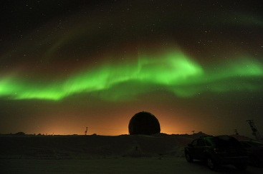

Partially applying this concept, of a bio dome that freezes, would it also explain how the Hindenburg collapsed into flames? For no apparent reason it went down. You see my dear reader, if you are a pilot; I’ve made sure you know the frozen bio dome hazard possible. Extreme cold is extreme hazard. How many winter crashes are regarded as unexplained or blamed upon UFO when the landing gear smashes into a bio dome that isn’t recorded by science to be there? Area 51 in the states is all about the blaming of UFOs for the infighting of the navy and air force about the ownership of nuclear technology that left the navy personal massacred for trying to steal a bomb before the Air force wanted to share the technology. The alien cover up is on purpose and mindlessly perpetuated by a government that doesn’t want anyone to know the extreme divisions of their own forces. The navy can’t stop being communist in my opinion, and the Air Force can’t stop knowing freedom.
Icebergs that float in the sky need to be webcamed for the south, but even then it’ll be denied.
Friday March 7th 2013 / -40 C / 5 am
XPPOND emanations of streamers
Defined as billowous coiled band (smoke staking out of the XPOND site) as an effluent of a smoke stake, the billowous extends over the cabin to the E Lake from the other side of the property.
7 am sunlight, but no sun yet.
I called Iqaluit research (useless) and Churchill’s Northern Research museum//institute (which referred me to call the university of Calgary). Dr. Phil Langel at the U of Calgary is at 403- 220 -5402 but other U of C numbers are 403- 220- 5385, and 403- 931- 2366. I remember how effective this is in keeping a reader, to supply telephone numbers, from calling the White house after reading about a number. So enjoy the authentication, keeping in mind that Calgary’s U has a ton of voicemail but very rarely if ever an actual human to talk to. It was very frustrating to think that Dr. Phil could help me figure out an electroplating of a tower when really it was the bio dome cracking, but at least the theories were voiced before perhaps the truth was found.
Sat March 9 2013/ 3 am- 3:30 am / - 30 C and very cold.
XPOND generating night/morn
XGUN isn’t active.
Small areas near XPOND reach bio dome height and form a travelling arc, which sweeps over the lodge peninsula to E Lake but only as a green mist without yellow flaring. Then it disappears. This isn’t the nls of last night… but I am groggy, tired.
Does the swamp gas/ UR/ chloride rise to travel on top the biome or underneath the biome and within a dome. How does it travel up, then across if it is heated or on helium so it can rise? What forces it to stop and sandwich crawl between layers of atmosphere instead of continuing its ascent? Why, or what is forcing it across the biome? Why doesn’t it just fall again?
I have not claimed to be an expert, and won’t but I can value the observations. It stops rising. It skids across. Does it burn a hole in the biome, escape, but is too heavy in the next atmosphere? You want a world class area to study, study this Lake. You want a mindboggling research topic, chose this one. I’m an avid reader, and have had access to divergent and convergent scientific thought in my life. I’ve tried to educate myself due to poverty, and also to keep my mind active and young.
So here is a story that is relatively unrelated, but may tie in if you think of it. What if natives burned Uranium as white people burned coal for generations before other options became available?
Franklin or Mackenzie, and I think it was Mackenzie is documented in a history of the north by Farley Mowat to have observed the natives burning a yellow colour fuel. Was this non-refined natural gas, oil, or uranium? I think the term- mud like – was used, but I’m unsure that is accurate. So if the locals burned Uranium because everywhere up north pretty well on the mainland has bits of it in various concentrations, would this abuse the physical body?
Historical accounts of the green stone in the water at Pangnurtung states that it wasn’t famine that would occasionally kill the people, but the water made sick from the green stone being exposed. Being exposed- as if exposure causes sickness- and remaining under water stopped the sickness. That is a radioactive circumstance there, but if the green rock was exposed, then it was in the air and not in the water so people were sick from the air not the water. Hmmm…. And the Pangnurtung is a place over on Baffin Island, near Nunavut’s capitol.
I really wanted to go to La Ronge’s radiation technology programme after leaving the north. For about 6, 000 $ tuition only I could have the tools perhaps to test and rate the industry, but usually industry decides the course content and industry regulations are self-policing while we are radiated into something that they really don’t care about, from what I have seen. Maybe my opinions get too much in the way of my career choices.
http://gosiast.com/programs-and-courses/programs/Radiation-and-Environmental-Monitoring-Technician.aspx
I’d guess yellow vapour…flaring in green mist…. Occurs only outside the frozen and cracking biodome. After a night of heavy flaring, clouds will often pile up directly over the lake itself, looking as if it were a thick and icy solid snow bank. Icebergs float here, so I wonder if one large mass of a snow bank can also float here also. I’m not the one to guesstimate that the weight capacity of a frozen biome is one thing or another, but when the icebergs seem to be floating downwards, it is clear that the biome has carrying capacity. I’m wondering if it carries things as a web like nylon stalking would also, there seems to be a bounce to the carrying capacity.
If you’d care to see this call www.southcampinn.com at 867- 252- 373 or 3838, as well as emailing them. You’ll have a flight in at Septembers’ end and possibly out in mid- May. So is a frozen biome a type of ‘sandpaper’ for flaring activity?
Sat March 9 2013 / 6 am / -30 C XPOND is emanating all across the E Lake area in a broad cloudbank.
Sun March 10/ 2013 no nls
Mon March 11/ 2013 No spectacular lights, but some at XGUN (crack?) area. Some will o’ wisp along airport marsh.
Tues March 12/ 2013 -40 C 2- 3 am / wind from Manitoba
XPOND activity gathers, rises, goes over rises, and goes upward and over “Blue Sky Bay” to form an arc from north to south above my head. Arc extends to over E Lake. Arc has a common defined bottom ‘altitude’ to denote a common surface. The top of the differing heights that make it look as if only the bottom is a common shared or defined surface and area. Biome lights appear to ride atop the biome, but only the first one, not being defined at the top, or so it seems.

Cross section of nls XPOND skidding activity

XPOND blue sky bay Lodge peninsula Ennedai- Lake
So here’s the question- how many of the deflated biomes combine to make the surface the lights skid over? Being a cook in the past, there are beef slices, turkey, cheese, pickles, bacon, ketchup, mustard and lettuce to name a few layers. In these terms, do my atmospheres look like a plain burger from MacDonald’s ($1 special) or do they appear to be a big whopper? How many layers are there in this biome I’ve seen acts like a …membrane? I cannot guess. There is a boundary, and already I’ve pushed science limits to fathom what I try to survive, but if all the atmospheres are collapsed to one then what is an atmosphere border made of? Why can air support icebergs unless there is some organic living aspect to this as in the case of separating the organs within a person’s body from each other. There is a name for that substance- mycelium. What is the name for the substance separating layers of atmosphere?
Tues March 12 ? 13 / 6:30 am
My back is wrecked from work, so there’s not much of an entry here.
Wed March 14 only overcast, cloud
Thurs March 15 XPOND activity in cold, cold sky. – 30 C at 3:30(?) am
10:30 pm – 30 C lots of activity
Dome shape as in an open dome stadium of nls seats, bleachers, and round shape. Usually I am sleeping, but maybe this occurs all nights, or often. My awakenings are usually about 12 to 2 am if I am up for the lights, so this timing is important- each night may start this way and if Walt Disney can showcase his everglades, this is the time to show the folks just why this is a winter wonderland. Nothing else can compare to this appearance of a solid light concept.
I am very straight forward here, this ‘in the round’ phenomena seems to have a solid in the sky appearance. Studying this feature is crucial to understanding light science, holograms, biomes, uranium, chlorine, marsh gas, atmospheres…it is all in this one phenomena, and all I can call it is a ‘stadium’. A person could play football inside it, as its’ lower extremities are close to the ground. In fear, or in cold, the reluctance to cruise and the inability to start a cruising snowmobile under this stadium is the loss of an experience that may carry a danger with it. What if it solidifies and crushes? I am talking about light here, but this thing appears to bulge at the sides.
Ever lose your mind over something incredible? Most of us would recall a sexual experience, but this… I cannot classify this in known science. This has a nebulous look to it. This appears like an organized cloud mass I have seen in space pictures. Just mind f#$%ing blowing. When the nls climb the rounded bulging sides of the stadium, it is almost as if the particles of UR are in small clumps that are singled into rising, then falling inside the donut shape. As they fall, they flare a brighter yellow on the photon stadium sides- into a yellowish on a blue like stadium. So why was the stadium so vast huge, and perhaps more of a greenish than blue. Just mind boggling.
A small map of the donut/ stadium phenomena in its’ arial view.
Dome begins in the bay, then moves out to the lake.

Dome is at the edge of the bay opening. You know As I write this, tears are in my eyes often because the sheer…whatever person could call …overwhelming perhaps of it. Truly phenomenal. And I sleep through this usually. Or do I? I keep trying to wake up, but 12 am or 2 am seems a really good at least 6 hour sleep time for a body without orange juice. No orange juice here, just jam. Makes my head a bit jammed, but at least it isn’t the lethargy of scurvy.
I tried going without Vit C a few days, and I don’t think I am going to repeat what might have been a week long attempt to avoid aspartame in my Jamison brand Vit C tablets. I suppose I should have boiled the bark of the trees for the pycnogenal (50 times stronger than Vit C), almost tried that. These trees don’t look like they will burn, their bark is all too knarley, preventing such a thing. Bark stops fires.
So there have been a few times at the E Lake when the place has knocked me out with wonder. Maybe the stadium doesn’t leave its solid light hovering over the bay, but an effluent of lights seem to trail off into the main lake area- just baffling. A person would really question this as a UFO with no background as this entire booklet puts out. I am not decrying the sightings at all, just saying that this is out of this world. What a mint this place will make when it is marketed properly.
I suggested one time that Az set this place up as Snow White’s Palace for a Disney destination, and I will not relent upon that, but the proper radiation disclaimer forms need to be filled for this to run as a successful winter business. Think Disney would allow its’ status as one of the world’s best investments to be tarnished by dangerous radiation possibilities? I don’t think it would, but I do think that we, the brave the free and the dangerous will pay as much for this experience as they do for space flights lasting 10 minutes or for a place on the shuttles that go ‘out- there’.
http://www.snowwhiteandthehuntsman.com/
Friday March 15th/ 2013 / - 30 C / 3 am (? Time is off from last reading.)
Very active nls. Lots of marsh airfield flaring.
XPOND glows, gathers, rises, then skids across biodome in straightlines. Blow over occurs due to wind skidded lights from Yellowknife direction.
This is clearly a swampgas/ Uranium mix of water cycle activity. Copernicus, Galileo, The Toronto board of Education and Gurbin- we have all contradicted common philosophy , in my case of the nls. In the case of the Toronto B of E, they are offering both options as viable, not chosing between hydrology and Van Allen beltings in the sky. Is religious persecution undergone by the TO. B. of E.? The ‘big T.O.’ is what you’d name Toronto when you grew up near it.
5 am XGUN and XPOND … spotlights! Very spectacular! Two streamers from both the XSITES connect and are about 100 feet apart in the center, but mostly they run parallel, displaying as green long ribbons- these join almost directly over my head above the cabin after a time. Very spectacular., and they eventually drift and blow away.
Sat March 16th/ 2013 – 35 C / 12 am It is cold, and lots of nls all over.
Sun March 17th/ 2013 – 30 C/ 1:30 am Tall displays in space. Quiet green mist. Complete Bay ‘Bowl’ has formed and has blown away from Blue Sky Bay into the E Lake airspace.
Mon March 18th/ 2013 2, 5 am Lots of faint green activity over both XSITES.
Tues March 19th/ 2013 / -30 C / no wind/ no nls/ clear sky
It was – 10 C yesterday so maybe this is too warm for nls.

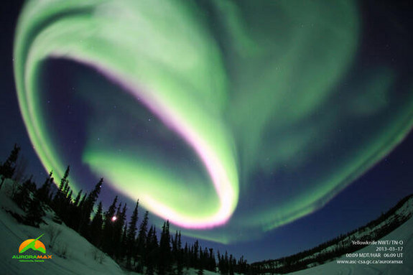

Luke’s Observations of the Northern Lights

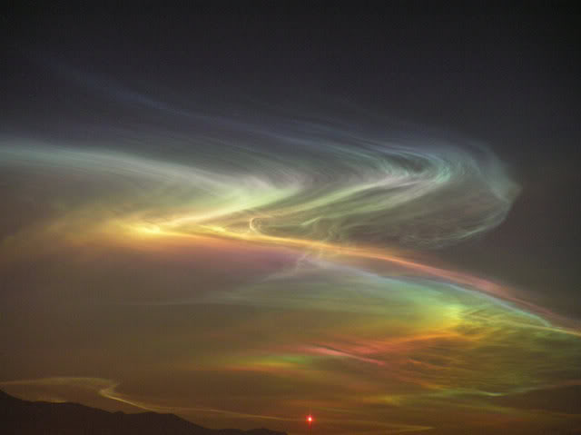

CHAPTER SIX:

Lynn Andrews needs to move her people- not only because no one I’ve heard of has tried corralling Muskox (twice the iron content of bison).

Wed March 20 /2013 / - 30 C / little wind
2 am light snow
3:30 XPOND XGUN streamers
5 am light pockets, same strands
6 am very broad glowing cloud over 2 pt. Island
2 pm Conservation officers Joe SR. and Joe Jr. from Arviat arrive and cruise in with their 10, 000 or more snow machines. We are talking very high tech here, even though they let their faces freeze to different solid colours, they have the snowmobiles that get out of the showroom in a few years from now. I’ve never seen these funky models before, but then again, I don’t live in White Courts’ yearly snowmobile bonanza and its’ biker turn snowmobile weekend travelers to.
I’ve never considered snowmobiles cars before, but the exact same parameters follow their wake- status, prestige, mobility, and flashing for the family appeal. These people are not suffering for mobility. If it were my choice, I’d spend my days after this winter by canoeing down the Kazan River to Baker Lake then Cambridge Bay then to Rankin Inlet to persuade officials that I deserve abandoned housing in Rankin. That housing was made by the government to rehouse inland peoples when the government claimed they were starving, not fasting. It is the land of cannibals and starvation up here, but the Rankin’s even tried feeding fish to pigs in their attempt to have farms there. Pigs seemed to require housing that made the project unaffordable, but what does pork on fish diet really taste like? I bet the pigs enjoyed the diet.
http://www.myccr.com/canoedb/routeDetails.php?routeid=206
I’ve worked with pigs before in their suffering cages of the farming industry cruelty. Few know or care of the pigs’ natural habitat. They root and dig for foods or rotten tropical fruit fallen from trees, and their eyesight makes me think they prefer nocturnal forest scavenging. I don’t think they prefer human daylight hours of industrial concrete, lights and mushy gushy grain dieting. I don’t think there is much crueler than a pig barn aside from a fox farm due to the temperament and natural environment these creatures belong in. Some German farmers are making pens of 5 or 6 now and trying to more closely mimic the natural grouping environment of pigs, but mostly in North Am they are industrialized. Vegetarians are hated in North Am, only being 10% of the population. We belong in the north east of the Caribbean, where the Seventh Day Adventists also have a strong religious following of Vegans.
No one I’ve heard of has tried corralling Muskox. The meat is very high in iron- higher than in buffalo. The muskoxen range more inland towards NWT and more to the north and on the north islands, but the summer caribou according to my readings of caribou migration, spend summers between Arviat and Baker Lake. In winter they move south and elsewhere, so the people perhaps do not have the muskox in the coastal area, but there is deer, or I suppose I should say Caribou. I’m not a hunter, I’m a fisher.
Mostly vegetarian, I’d claim it is why the brain activity is active in this region, but mostly it is quieter. Vegans with tons of Vit C act brainier, like pigs on fish. Happy pigs are rare, but I’m guessing that the happiest ones, even in confinement, were in the coastal pig barn that Rankin once had. You’ll see when the rail extends to Rankin that grain will ship to the area to try traditional types of farming in the area more affordably. When the roads are in all places on really funky cruising snow machines though, I doubt the rail will have its extension from Churchill with local approval. I’ve seen conditions in Saskatchewan that I think could farm in this area. A vege-head in Ennedai- I might a been the first.
I didn’t float the Kazan, as I knew that I have one hour before my injury stops rowing- I’d learned that years before on a conservation area with a boat rental I used to visit. I could probably sail a micro boat though, as they do in the all- around Florida marathon of the fabulous Water Tribe people.
www.watertribe.com
Joe and Joe (These fellows are about 30 or so years apart, so dare I call them the Jo-Jo’s? I’m a bloke from Funtario I suppose, knowing just how serious the West can get. Language is religion out West with no people, no soul, and sucking the wealth of the industrialized efforts of humanity. The French and Indian warfare never ends in Canada, only the USA (expecting us to be nice and kind and extend our concept of Canada outside of human areas). Jo & Jo are on a return cruise from Arviat to Lutselke, modern ‘snowball or snowdrift’ for southern tourists. The two stay a while, see me making my solar window greenhouse (this adds 30 degrees in warmth when the sun shines on it) that I think I need because I cannot know if I will run out of firewood. In hindsight, I just recently told Az about firing a gun into the air to scare off any potential lurkers in the first month at the camp. It is now the end of March, so I’m not going to be impressed by a couple of month time lag if the idea is just that.
www.tracychapman.com
Tracey Chapman’s immortal song about ‘the cops never arrive and if they do it is always too late’ rings my memory as I try my best to entertain what will be my only human visitors that I meet. I’d say that Inuit may have a more humane environment than Western Canada, but I don’t really know, and the E Lake lodge borders Manitoba. I have tried to be fair to the Westerners to learn their cultures and live in their lands, but time and time again they try to destroy our lives and pretend to be human. Inuit seem English though, so that’s okay. Tracey seems human, and her website ‘stop-wows’ a person.
Hopefully Ontario separates one day and is free of France’s Indian empire. Lots of them can’t even swim, pretending that Al Capone wasn’t the second Louis Riel. They love their gang behavior out there, even though Alberta might act the part of English from time to time. All the earth’s conflicts seem to start and end in the UK (it contains all things, unlike similar quips about the monophyte innocent games of the murderous USA and their 3,500 religions pretending to be separate from great Satan hiding from the Muslims in Canada, Hamilton) and even Irelands’ current Prime Minister has decided to rid the humans of the Catholic pedophiles to make better business. Try that in a place of 3,500 cults.
Having said that I might have missed a few chances to meet the locals outside Hamilton. It is however still Canada- complete with its’ hidden and illegally obvious and inciting death cult. I am early to bed and early to rise. I have heard what may be the foxes outside the door, but also have heard in the first few days the freezer doors opening in the middle of the night. I changed security at the cabin to ‘locked’ while the rest remained open only after a few days in the wilderness. It isn’t something I care to repeat- having night visitors inside the cabin, but on the open air concept deck area where the deep freeze was located. I did hear bangs on the door on more than one occasion, eventually calling all the local Hunter and Trapping clubs that ring the area and introducing myself as well as letting them know to knock on the door during daytime hours, not at night.

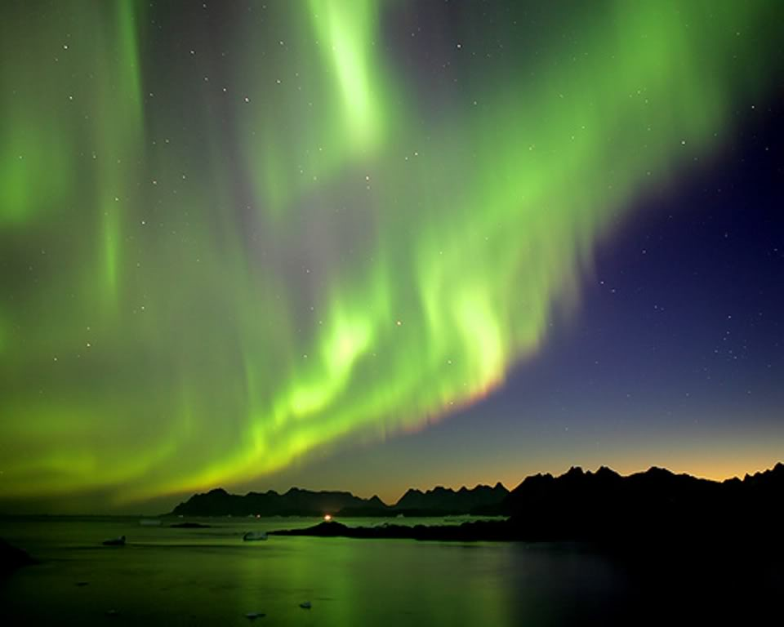

Stories of people’s foot soles falling off due to unprepared travel in the north are not uncommon in literature, both for Hollywood type shock and for avid reading. But these are conservation officers. Why would they not have scarves to preheat the cold air and to protect the face freeze? Macho behavior is all over western Canada, and stupidity isn’t much different. Holes in the face are not obviously a concern to the seasoned travelers here.
They do not stay long. I smell. I just shaved the sides of my head, lacking proper head shaving razor technology in my hologram solid light stadium bay of bays. So much for hospitality. Old Joe won’t have the Fennel tea. He probably tastes the old leaking solar batteries in it (lead chromium?) Me? I’m living on tea like a good Englishman. Few traditions can go wrong with tea time as a prerequisite to humour. The Japanese have it wrong, it isn’t about religious performance. The Jones’ might need to brag, but the tea itself is about water that the West can never swim in. Why do we have to allow them in Canada or Ontario? Ontario can’t survive the USA military past without French Quebecois, but it is a mistake to allow the West citizenship. We are forced to tolerate the French according to the past. The West wants to pretend there is no water.
Seriously, Alberta was almost bilingual in Ukrainian and I have observed the Catholicism of the Czar heritage is a Catholicism Quebec will never counter. Historical Czar Alexander, so-called defeater of Napoleon, would make a military effort to rid the Crimea and Ukraine of single people, no matter their age. We in Ontario chose whom we care about, not having to settle for aliens whining about racism because they are hiding in the human environment. Even in- province, Premier Harris couldn’t himself find any gratitude in Northern Ontario after building roads that didn’t need to be built. I think Ontario deserves better self-preservation, and also tea. Were I to be English, I’d enjoy the very new Ireland’s business environment instead of Canada’s. Alien reject victims are often very human. ‘There is no water’ means there is no truth. Sickness is in denial, or Western Canada, and their lies don’t stop at water.
I try to call the Joe’s the very next week, to find out about the extent of the new land claims in the area. I don’t use the TV for news and there is no radio. When I get back to the south I almost immediately find out that the ‘Sirius’ satellite radio may or may not work up there, but it seems to be on the maps of possibility. Many times my noon ritual was to listen to an hour of music, and maybe dance a little to be human in the barrens. I had all old music- Ella Fitzgerald, old jazz, theme musicals on tape- all on tape, as the CD player wasn’t playing. Old music is okay, but the funkiest I heard was a tape that had house music, and the John Denver music was played more than Dolly Parton. The Denver tapes were produced annually, numbering three tapes in a row, so watching his maturity as a person and into an openly demonstrated love relationship was a fine thing to behold in music and in his daring to be monogamously free with his woman. Clearly, wonderfully, he missed his polygamy lesson.
So I looked like a shaved freak with a Mohawk to the cops…really good impression!
Farley Mowat claims that the olde people would travel from Churchill to north of Yellowknife to a place called Coppermine (modern Kug) to obtain metal for tools. The range they travelled was the Stoney range, not much above 2000 feet, but far more important to the north than people know. This range divides the NWT Mackenzie lowlands from Inuit territory. As such it is a neat division in modern day’s map area to define Inuit from Non- Inuit. When fathoming why the four corner provinces and territories differ from the four corner states down south, the Stoney Mountains are the reason. The cold endures almost to Black Lake near Lake Athabasca in Saskatchewan. The divisions are near enough for cultural/ climate to be defined however.
After 50 years of negotiating, I think NT territory is well partitioned, except for the luxuries of the Inuvik peoples in the 1950 government town almost on the Beaufort Sea and near Yukon. Those people are in the tree line. It is a funny line, but those people are near Alaska, so they have federal government support and Alaska/ Yukon infrastructure very nearby. People actually farm close by.
It gets warm in mid- Alaska on the Canadian border, but that stops at the Rockies, and only again starts in the Mackenzie lowlands, mostly south of the Yellowknife area. The tree line can be said to follow the Stoney mountains, but on the Mackenzie lowland side, not the other windswept barren side. It isn’t an accurate thing to say, as the outcrop of another tree line occurs in the Baker Lake Thelon river area to the NWT border, but I think, after seeing this area more fully, that the tree line may be a radiation line.

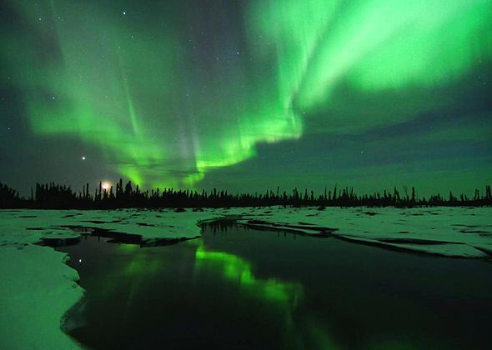

You think I am boggling your mind, but wait for this one- what would the nls look like at ground level? The Giant’s Causeway, in-between Ireland and England on the Island of Manx. It isn’t the Island of Man there as some name it. It is properly called the Island of Manx. Names change over generations, but the pirates of Manx have a name that they have with their culture, and the history ought to be respected.
So a ‘Giant’s Causeway’ is nls ground level activity without a supporting biome.
Pangaea to me is a smaller planet, before expansion. Fast or slow, the puzzle of continents only fits on a smaller area, such as the moon. Then the continents fit together. Ground level nls might have occurred at some point, or some altitude, or in some rotation. The ‘Chicklet’ fallout from the icebergs in the sky could occur at a different size, and that would make a radiation burn into rock look like the Giant’s Causeway.
Also, did the olde people make tools from both copper and gold abundant between the two huge lakes of Bear and Slave? Does even one occurrence of Uranium fallout keep the Caribou from an area and prevent trees from growing on the barrens? The earth tilt in winter is also a factor- the earth itself tilts and contributes to the barrens of the Kivaliq region being what they are. But if the vegetation has no resilience, the trees irradiated by the rare iceberg fallout may simply cease to grow in an area of the Canadian Shield that has abundant Uranium.
I’d guess from reading about natural resources present in the north that a third of the entire north is in areas that have Uranium- and I mean the settlements up north. In the studying of mineral potential, most the areas in the Kivaliq region north of Manitoba and on Hudson Bay seem to be both Uranium and Canadian Shield areas.
The shield is almost as fluid as the tree line when its’ geological presence is traced from the Melville Peninsula to encompass the eastern mountain range of the Baffin Island expanse. The shield doesn’t encompass the areas on the coast near Cambridge bay, and those peoples are not according to the maps, in danger. They are in other geology areas. The Gjoa Haven is also out of the Uranium potential area, but not its’ neighbor across the eastern waters- Taloyoak on the Melville Peninsula.
In my opinion, people who want to live in the north should live in Cambridge Bay. Inuvik seems also a good place except for Fort Mac’s oil sand pollution pouring down the river. Yellow knife seems a place to survive, but the closer to the Rockies, and the closer to the north shore line seems to be places to avoid uranium in the Canadian Shield. The Shield ends almost at the eastern expanses of the Slave and Great Bear Lake edges, and doesn’t seem on the map to include Coppermine. You could say that the Canadian Shield is the tree line between NT and NWT. I’d say that freedom from UR is not living in the waste of the continental mass before Hudson Bay. Pangnurtung has oral history, being on the Shield, of UR causing people to be sick.
So what did I learn up north? That is unique and very potentially dangerous, but only if approached from the wrong place. Could millions of people in the Mackenzie delta one day? I can see that. I cannot fathom people living east of Yellowknife due to radiation concerns, in large numbers. I don’t fathom a clean-up like I fathom Fort Mac in Alberta as a puddle that needs cleaning up. Cleaning up ground chalk called uranium could only involve a nuclear power that might have a devastating chain reaction, but is interesting to think about. I wonder if a similar field exists in Russia that all the commies could be dealt with in one domino effect they haven’t considered. They do so admire their ‘global world domination’ cold weather behavior, and their polygamist Czars. The USA wants their screwy leaders almost as badly, but English tea survives it all.
I told the conservation people I was also at E Lake for a spiritual reason- Lynn Andrews has books about her teachings from Elders about one hour drive south of Thompson, Manitoba province.
www.lynnandrews.com
Lynn’s information/ experiences range the globe in her quest to fathom jaguars and Tibetan peoples. Lynn’s peoples seemed to seek consciousness as humans, but I think they should move away from Saskatchewan’s huge radiation field known as the Canadian Shield.
Were I a government person, I would relocate all the non- economically engaged miners from north SK and MN provinces to either the Mackenzie lowlands or to the Woodland Buffalo regions of northern Alberta as it does not have the Canadian Shield according to maps. There are also areas in mid Yukon that get warm as does the Fairbanks areas.
I’m not a government agent, and all these areas I have mentioned have low populations and industrial compromises that make people both silent and not knowing other improved standards. People out of Alberta do not know that the winter jobs of Fort Mac outweigh all concerns of Prairie people. Environmental appeals from England’s Green movement really do not know how starving and poor people simply want work.

Luke’s Observations of the Northern Lights

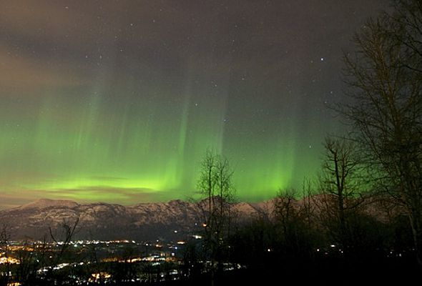

CHAPTER SEVEN:

ICE LIGHTS! and moondogs and skyquakes- OH MY!

Thurs. March 21 / 2013 2am
It is as I thought.
There are Moondogs.
Just as there are sundogs, there are moondogs. Sundogs occur often here. Almost every March day, due to sun/ earth alignment. What is unusual is the way sundogs at this location seem to plow through the lake or islands, as if a solid laser.
So how can light be solid? If it is frozen of course, as…{pump organ intro in the background}
‘ICE LIGHTS’!
The intensity of the sundog causing eruptions at ground level seems more intense when the sundogs hit the land, not the lake ice minerals. The sundogs are sort of a giant raking occurrence that has a third strike area just directly below the sun. Let me make this clear, the sundog rainbow appearance is on the outside of a halo the sun makes, and the sun is for the most part in the center.
Lengths of the sundog height can vary, they are not seemingly to obey any short stub of light rule. This place just rocks a person’s brain, okay? When in contact with the ground, the sundogs seem to make an eruption. I’ve got to learn to make literary pauses for the dramatic silence to stop at places such as this comment. I’ve also a mind to think the sundogs weakened or opened a swath of lake to the water beneath it, but this was during a warmish time it may have been possible that Kazan’s lake current could have experienced a surge into the Lake Ennedai waters as it emptied here from across the NWT border. The sundog phenomena occurred at the same time in the exact place at the base of the hills across the lake. I haven’t been so glad to see water since I left the prairies for the Philippines a few years ago.
What a nice thing to have water. I grew up with water so it’s an inner child thing with me to crave it. Some people know home as other places, but water seems to be something of home to me. So the open water was a study in plausibility. Water homes can’t pretend the prairie ‘Capone’ denials.
Warm radiation hills may have opened the ice, warm currents from the watershed may have opened it, but the rest of the lake had 10 feet of ice that Az who never saw the place before and never cracked his back a month every day for fish but claims is only 6 feet deep was the expert on. I am being terse her, and it’ll be ill received, but the fellow is just off the death of his Mom- in Law, so all things need to be put aside with him for a few years.
Just sending Az a copy of this book in the snail mail may have been too much for him at this time, but I’ve recorded what I saw as was requested of me. He seems a resilient business man, so I don’t think the grief will stop him making business decisions. It is hard to tell a person only over a 5 month period, outside known cultural perspectives, and not knowing other stressors. I’ve been trained by Guelph Hospice. It is also incredible how the ‘psychic’ occurrences in a person about a month before ‘passing over’ can detail what life really is beyond business and tradition. Dannion Brinkley has interesting perspectives on death found at his website.
www.dannion.com
I fear he’ll never have the love relationship of a type that John Denver found. It’s hard to see all that effort wasted. I emailed that to them, and his wife asked why?
So Az says solid light isn’t’ science. Az says snowdogs are refracted light. I used to think this also, but I watch as refracted light grows from 200 feet high on the horizon to 1200 feet with an iridescent white shoot off… and this place boggles my mind. I name that iridescence a ‘sunwing’. This makes me think of olde comic books and the name Robin of Batman’s fame gives himself in the comic world, but this is no ‘Nightwing’, this is a sunwing.
You see, if light is water and the sun is in a form of water, than light is or can be more physical especially in an area with less atmosphere. Solid light is a challenging concept, but also a very cutting edge concept. Just imagine, a physically solid rainbow that both breaks and moves the land as if a plough from a tractor implement. What is the science of this? Instant roads through the Amazon basin to connect people and products. What is the application of this? Instant mines dug into areas of high ore concentration. Instant harbours, instant vaporizing of the oil spills of the Exxon Valdez. Instant nuclear accident cleanup.
Science is different here… I know better than to say this to Az.
Moondogs. The sun parts the clouds, and light… or A light science is revealed. The moon intensity also parts the clouds- the intensity of protons to move H2O or atmosphere particulate is important.

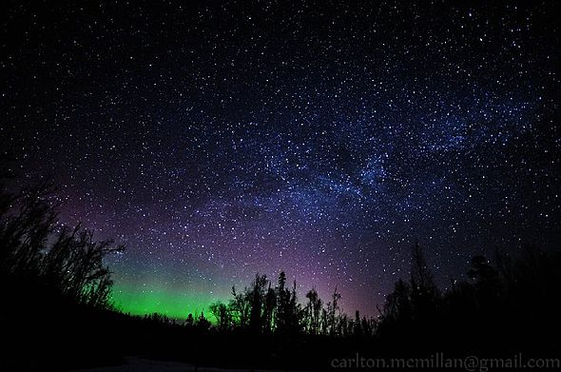

The Moonbeam makes its’ path tonight over the XPOND site, as it splits the nls into 2 separate ‘dogs’ on the sides of the moon ray perimeter. This isn’t osmosis. I’m going to call this one into the University of Calgary’s Dr. Phil Langel and Emma Steinbeck. It is significant. (I do have both their names incorrect).
The moon is strong enough to rule nls as they split into 2 separate ‘moondogs’ on either side of the moon. Not a halo, but 2 separate distinct blotches of nls at 0 degrees and 180 degrees from the moon horizon (3 and 9 o’ clock in visual terms) from the moon. Very little other nls activity is occurring at 1:30- 2 am. Moondog occurs in the Yellowknife direction according to mine on the map, not any magnetically screwy northern location attempt.
Which brings me to the topic of the movement of the north magnetic pole. It used to be farther south according to explorers about 100 to 200 years ago. The slow ascent of the magnetic north pole is a very curious event. People grow taller, so why not the pole? The occurrences of hurricane paths in the last 20 years has undergone an ascent into the mainland of the USA that did not occur differently before that for years and undocumented years. These movements of hurricanes and the north magnetic pole may be natural, may be part of long cycles, but also may be part of a new occurrence in the globe itself.
Imagine trying to keep everything the same as the globe travels the rough the Milky Way at 23, 000 according to one source, probably a popular science magazine I read as a youth.
Maybe it isn’t weather war occurring, as was outlawed by the Geneva convention in 1953, as Russians still use the science to clear Moscow’s airport of fog. Hurricane paths moved from the mid or top Caribbean to the inland southern states. North magnetic pole recorded to move from between Gjoa Haven and the Cambridge Bay area to almost Resolute or maybe north of Resolute Bay now, where boss man Az resides with another 1000 or so people. I’ve got to check that population stat again, it may be only 250 or so working in Resolute.
Moondogs!
a small picture depicting the moondog occurrence
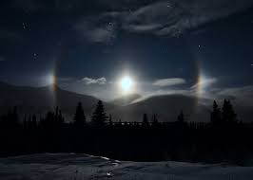
Moondog nls gathered to 0 degrees and 180 degrees at level with the moon.
Moon beam perimeter not much a halo as a ‘punch’ through the sky.
The sundogs act different I think, as they seem to bite into the earth and then follow the sun with a bit of a lag and longer tails still dragged into the earth as the level horizon of 3 and 9 o’clock or 0 and 180 are almost appearing to be dragged upwards and out of the earth by the sun rising with it’s followers.
In hindsight, the radiation hills to the Hudson bay direction may not allow such a moondog dragging up to occur. In hindsight, I didn’t watch the moondogs long. Was the nls material gathered and squeezed on top the biome as moon beam cut the atmosphere? Would or did moondog location change on the 0- 180 locations as the moon ascended and descended?
Moon dog questioned altitude as followers or leaders of the moon halo effect in picture form
All I saw was 0 to 180 and it was very cold. I didn’t see 8 o’clock to 4 o’clock nor 10 o’clock to 2 o’clock.

Thurs March 21st 2013 – 20 C 4 am
Hudson Bay blow in- only 1-2 km visible. Some of the fiercest storms are from Hudson Bay and I’ll bet the most rain in the summer is also from H.B.
The moon is setting over the XPOND
5:30 am Not much nls activity in the sky and it is very dark without the moon. Hudson Bay winds may knock out nls activity.

Friday March 22 2013 temp? time? Wind?
The true tree line has been talked about already, so I won’t add more now, just a funny map that people may discuss. There’s a way fun maps site out there:
www.timemaps.com
Tree lines and civilizations seem both to jaggle in history. When is a tree history? The answer is when it is hers, or ‘herstory’. I just made that one up.
A rough tree line map of the north that this Chillbilly thinks is relevant
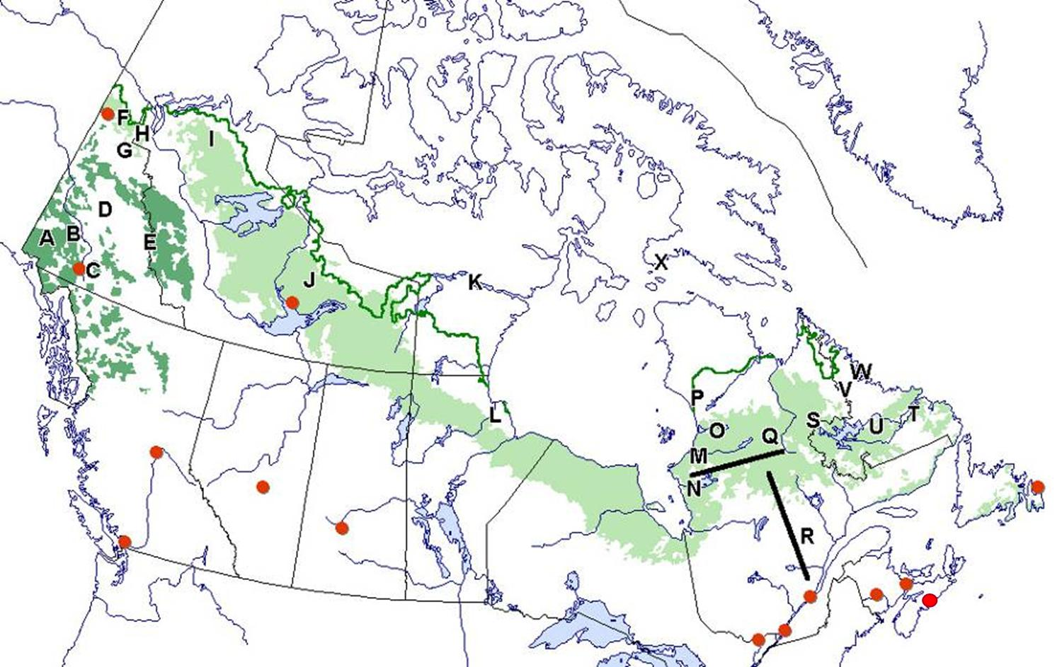
Some atlases list the Arctic Circle as a tree line or limit and it is misleading, either to the true tree line, or to wishful thinking. There are bog areas in the way far north that provide living soils if the trees can be planted there. So the thing we witness in atlases is an attempt of some bloke to pretend the trees occur in great masses below the Arctic Circle. Northerners won’t understand this point, but the tree line isn’t a factor in the southern brains.
Beer is. Food is. Territories are. Jobs and tribes are, but the tree line is one of those transcendent things so far from the imaginary that it is like telling the Catholics in Europe not to invade Catholic Poland. For a thousand years the west pretended Poland wasn’t Catholic. There is no logic to it, and not stopping the sheer hatred of ignorance, book burning, religion and popular loyalty. I think the ‘Children’s Crusade’ or even the first crusade really shows just what mindset could perpetuate the elimination of truth.
So the tree line sort of follows the Stoney Mountain range that isn’t named proper in atlases, because it is not in the consciousness of the mappers.
Mom thinks we live in a great age. She lived the 45- 70 era in her youth, and that was indeed an epoch, but this isn’t an era to talk about as that was. Reorganizing under a global currency, things are forever different now, unable to return to that time of … dare we say few conflicts? People were tired of the WW2 death cloud. Kug (Coppermine) to Churchill, with a scoop to the Saskatchewan border, and a moustache at the Thelon River/ Baker Lake entrance of a tree line. Chernobyl is now the same radiation as Denver Colorado according to one magazine I’ve read, but what if the Inuit put up a grid of radiation detection throughout the Kivaliq region north of Sk and Manitoba provinces?
Accurate readings would be helpful, but I will tell you why the locals won’t do this. It is the same reason why Greenpeace shows Fort Mac Murray oil sand activity in Liverpool, England, but not in North America. It can’t be done and the locals fudge the results. In the south, arsenic in the water is tested only once a year. That occurs in the November, after all the crop sprays have a season and after the rains bring an abundance of new water to fudge results. The burning waters in the south thus have industry sanction and seemingly are approved of by the strictest of government guidelines.
http://www.visitnorway.com/en/Where-to-go/North/Kirkenes/Hunting-northern-lights-with-the-Sami/?media=video&autorun=true
The traditional behavior of obedience and refusal to question the communists in the West really destroys accurate science, so non- embedded people from elsewhere in the country would have to be hired out to do the monitoring if the Inuit want to act as the southerners in West Canada. I am of the opinion that a few days of radiation fallout from the nls would make the occurrence of the region called the Barrens.
I would call the Barrens the Radiation Barrens if I were able to rename them, as I think it is relevant. Tradition says few people live there, but this may have more to do with radiation than at first glance. In my opinion, the area I was in could support a large population, but what would they do when they all collaborated to escape the radiation? Where would they go?
So if the animals avoid radioactive areas so that there is no caribou some years, would the relocation of peoples to less radioactive areas be a government occurrence? I wonder what the stats are about the people returning north once they leave. Do Inuit return home when given the option? I think if I lived in the Colville Lakes above Great Bear Lake, or Trout Lake, on the Alberta border, I’d consider home to be ‘up- there’. Home is a powerful thing. I do Consider E Lake to have been a home. It wasn’t a place I planned to leave. But I have a legal circumstance that I want to end to protect my folks from.
I would have been happy in the north I think, for the rest of my life. The radiation is something I would have abandoned for Holman or Sachs harbor perhaps, far from the downwind of the uranium. Damn radiation. I never saw it ending. So there are many factors to consider, not just one, but I do not think a local effort will ever monitor radiation. They will all soon leave if the truth was known to them is my opinion. Again, I think relocation to Holman, Inuvik, Sachs harbor are all plausible, and also to the luxuries of Cambridge Bay, but I think the capital of Inuit territory is wrongly placed, or the territory is wrongly partitioned. What do I know? Cambridge bay has a good start as a capital.
Today’s modern atlases do not show the Inuvalik territory cutting off Yukon from the Beaufort Sea, but that is what has been in existence for ten years now. Today’s maps also miss the divisions in South Africa.
Those people in west Inuit territory perhaps interact more with the Slavey and Dogrib tribes of the Yellowknife area and also with whiter cultures ‘up there’. Time and money, Cambridge Bay is a more natural capital than Iqaluit in my opinion. But I am not an Inuit either that thinks it is normal to hop on the dog sled or snow machine to visit the folks a thousand miles away.
So I don’t know, but I predict Cambridge bay will eclipse the relevance of Iqaluit, and will separate Nunavut due to the Coppermine tribe/ ‘Inuvalik’ language divisions from’ Inuit’. This has happened only in a small extent in the north Mackenzie delta on the sea. I predict that group will grow their influence. When Inuvik is as Yellowknife for supplies, Cambridge bay will draw to Inuvik and not Yellowknife. The people trade and do business in Yellowknife, it is closer, but with drone delivery of supplies, that will change.
When robots automate mining, the depot will become aboriginal Inuvik to keep the homeboys and girls working, and at home. I think I have mentioned an effect called ‘sheeting’ but it bears reiterating. Thunderstorms in the south are something that the science knows displays a ‘sheeting, full sky’ effect. So too does the nls activity display a sheeting effect, but I think of it more in terms of micro earthquakes than water or electricity in the sky.
In south Ontario, many small earthquakes occur and there is never a large, take-them – all – out type of quake in the Queen’s homeland area of Canada. Many small quakes prevent a ‘big- one’ and I think the ‘sheeting ‘ effect I witness in the nls is a similar thing, keeping in mind the biome is perhaps frozen…or maybe just cramped. If long lines of cracking- dead straight – occur as perhaps they do here (500 meters long in three sections, or very rarely, a single 1500 line) then sheeting as a skyquake is possible. Skyquake…what a term. North science is unique.

Luke’s Observations of the Northern Lights

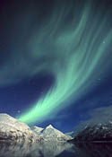

CHAPTER EIGHT:

Save the Queen, not the Wi-Fi.

Friday March 22 temp – 20 C 7- 7:30 am
Sundogs rise with the sun to a certain point, and then are gone. Do they fill the region that makes the moon red before turning the familiar white in the blue sky that most people see? Sundogs rise, but not necessarily stay connected to the earth to an elevation of about 1200 feet, very similar to my hot magma flaring orange moon on the horizon, and then the sundogs disappear. Are the sundogs phenomena occurring in radiation? Are the sundogs only a radiation occurrence? Are rainbows a radiation occurrence? Rainbows happen after or during rains depending upon cloud spacing. Are rainbows dropping radiation into the ground level from a higher atmosphere? You see how this place boggles the mind.
Sundogs here seem to have early morning Suntails- white blowoff sunwings from the sundogs burning or plowing the biome, atmosphere, or the ground surface. Ever watch a car racing in the salt flats near Salt Lake City? See the dust kicking up? I think that is what the sundogs are doing here. How can light kick up a storm unless it is solid? I suppose I could say they are sunplows, but who would concur that light could be solid ice? Water and light science doesn’t need an international space station to study it.
I have left a petition on Dr. Phil Langel’s voice mail to build a science research station here. Peopled by interested enthusiasts, they would see how Blue Sky Bay blows snow into E Lake that seems to be a solid ground level light I dared not to enter. Partly due to a wind cresting line, but the wall seemed a solid mass that blew the peninsula wind over the lake ice in a very straight line. It too seemed iridescent, similar to the sunplow flaring. What is it with all the iridescence here? Is that all uranium acting upon a motion created molecular irritation or something? And I do mean a wall. You could put a bullet proof cone down and into this wall and it would twirl around inside to make a tornado. Very rarely does a person see a defined wall of wind and snow. What a place this is. Light studies here may reveal a phenomenon of solid light yet.

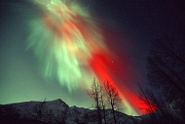

Sundog, sunwing, suntail, sunplow, skyquake, and a sunwing! What else is going on here? Let’s play a logic game and imagine….what follows this group…2, 4, 6, 8…sundog, sunwing, suntail, sunplow, sunwing, sunpot is my guess, or sun (plain olde sun) or maybe a couple of other multiple answers such as sunwave, sunhill, sunball, sunlens, sunberg. That’s a good one, a sunberg. Imagine the Sunberg falling out of the sky. Would that be a missile? Fusion power/ hydrogen.
This area is a Niagara Falls of natural phenomena and could easily be a research area of a great many sciences- nls, light, biome, and more.
A wide laser beam of white light descends directly from the earth to the sun. or is it the opposite. I’m really not doubting that some science claims there is no heat from the sun, just a light that catalyzes and draws forth the heat of the earth. Heat is in the water. The 90 degree or so normal range of a body to 100 degrees is partly to keep our body water fluid, but the body that goes colder may experience water without a continuous boil. We repel infection in 98 or controlled boiling of the human body. To control the body temperature is interesting, but I see a beam of light between the earth and sun. This beam is wider than the sundogs, or maybe just because it is all white I think it is wider than the rainbow sundogs.
I’ve attempted to contact Farley Mowat, as he’s been here for a duration of time. I don’t know if he was here in a January or March because J & M are high freak-out times here for variety of experiences with nls. He’s always busy writing more for his trade. He may also have experienced solid light here. One of his web contacts I found later says he is done writing, but who can stop breathing?
I’m going to guess that Inuit/ Canada interaction be fraught with not only cultural differences but of science also. I would guess the Inuit consider themselves a world apart and know that that world will never be known by most in the south. We may seem as cultural assholes to them. Similarly, because the Inuit land claims not only are traditionally inside of Hudson Bay but also outside Hudson Bay to Newfoundland, the distinction people throughout Canada claim on the Newfoundlanders might be considered a type of Inuit bias. Newfoundland is where you can depend upon the ice sheet no longer forming in the waters of the north. It may have tons of ice bergs, but it isn’t a continental sheet in St. John’s . That harbour also doesn’t occur on the north tip of the island due to ice cover and other reasons.
Sat March 23rd 2013 -15 C only 12 am- 12:15
Hudson Bay wind, but not severe. Ice wind, ice air, little nls activity. Five miles visible.
1:30- 1:45 am -20 C bitter Bay blow-in and down to 2 km visible as a storm moves in and there are no nls.
3- 3:30 am Just cold, dark, and the fogged over moon is setting.
5 am dark, icy, frost covered {…illegible…}
You have to recall that at some times, the solar array doesn’t have the juice as it does on a full sun day. After a few cloudy days, the lights may not be in the exact best of working order, so I may be on Battery power again as I first learned to when arriving. In the dark of the December hours, with only 5 hours of good solar array light I would charge the batteries for the flashlight. They were plugged into the wall and of a construction type that plops into a charger for an hour or so and then is put into the receptacle of a variety of saws, jigsaws, cutters, or in my case, a light attachment. I’d sometimes charge a group of about 6 batteries found in the garage and tool shed after a long night of darkness. The lights didn’t last very long while I was there. So even though I learned to turn them off a while and their fluid would revive again for a while I did have options.
When I couldn’t read or write properly, it was often due to the battery intensity or the background lighting not expressing a full range of language. The dark records the words, but are they legible in the light? Dewalt was the make of the batteries, and there were a range of plugins for their use. Dewalt is black and yellow, and the batteries were black as the tools were yellow.

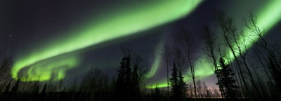

I got to know why a single boy in Malawi was a celebrity in his country. My folks made a ‘peacecorp’ medical time in Malawi. This young fellow, now on a scholarship to study sciences and also engineering I think, made his debut by building his very own windmill in Africa. To have light in the night is to remove the fear. To have light at night is to try to remain human. In isolation, and in limited foods, and with leaking solar batteries and throw in the uranium possibilities….something as simple as light is something I thought I understood in Saskatchewan. For a whole summer one year I had my mortgage paid in two months, but no power until the fall. The ‘boy’ was William, and he is now 24 or so in this year of 2013. The second site seems to be from his popular younger years as a wind shaman.
en.wikipedia.org/wiki/William_Kamkwamba (this site won’t autolink)
http://www.cheetahblog.com/the-boy-who-harnessed-the-wind/
Not relying on outside help and not complaining, I was quite happy the electrician would receive two payments instead of one outright payment for his service. I suppose I put the money into fixing up the small house, bu. So I knew not having light a bit. The street lights were always on though, and I could go down to the business areas for a splash of greater intensity.
Here, it was very dark, without anything but the moon or stars on occasion. Will, he taught himself basic wiring and had the scrapings to find a welder to make a good tower and wind vanes to have light from electricity. No one else in his village did and they all thought he was crazy and a fool for wanting light, but they were all jealous also. I thought I could understand why he didn’t tolerate being in the dark when it was possible not to be. No light, no people, nowhere to go- that’s my Ennedai Lake job duty.

Sunday March 24 2013 exhausted
Mon March 24 2013 12 am – 10 C no nls H. Bay wind
2 am -10 C no nls 1- 3 km visible
4 am -15 C no nls
Open water across the E Lake at base of east hills just a sliver maybe 300 ft wide by 1 km long. It is nice to see the clear blue water. If only I could figure out how to fish there and not drown! A canoe would be great, a kayak better. (I only see in the very last week I am there that there are several boats buried in the snow where I couldn’t even see a trail. These boats however, are very large, heavy metallic construction built for the weather. I couldn’t lift one as a cripple. They also all seem motor powered.). I’ve only access to heavy boats all up on stilts for the weather- with motor names of Honda and Yamaha. Maybe I’ll build a plywood skiff as I’ve read about before. Those skiffs however, all include embedded floating devices that are aft, stern, and occasionally at the sides.
It wouldn’t be fun to drown. Out of the north into the libraries I live in in the south, I read of a fellow who would shave an entire tree of its bark and build a single bark canoe, but inexperience doesn’t have me thinking about that possibility. And I do think of the www.watertribe .com or org boats I’ve read about. These are hybrid micro-boats often built to withstand both rowing and sailing in both open water and streams. The Water tribe races around Florida so they must have adequate travelling means for roads, (often bikes and carted vessels) and for rivers and oceans.
One thing after another, I also think of growing beansprouts indoors for greenery, and for salad. This would entail a container, soil (I found sands at two exposed places) and seeds (air- flighted in) but each time I tried to improve air quality with plants in the middle of – 35 C days, I suppose I also got to thinking that something else was a priority. OR, sometimes something else like the cold stopped me thinking. Today, I stepped in fresh deep snow.
I’ve seen the foxes create what I thought was an electric shock in the snow, thinking it to be a form of static electricity. In dread, again and again in dread, as my foot was pulled out of the deep hole, the hole was the same green colour as the nls.

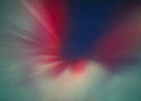
Deep snow usually has a blue tinge to it as light reaches through water. So the proverb is “echoes thoughts as a cave echoes sounds”. What is this green snow? I really live in dread of this place. Time after time, the threat of radiation seems worse and worse. I make this place my home, then I get scared outta my wits. Was that a snap to the nls green UI saw when my foot was in the lifting from the hole? I grew up in a nuclear power station area, but this was something out of my comprehension, or just an isolated dread on top of all the extraterrestrial chanting and bully behavior.
This f#$%ing place never stops showing more and more reasons to not live here. Usually a person makes a home where there is a future. Green snow makes me think there is no future here. What am I, the incredible hulk in my green terrain?
I look in the mirror this day and see green nls colour eyes. I look again and talk myself out of what I just saw. What I cannot escape is how ancient seers and Taoist monks of Huashan Mountain of China would drink only mineral water and have blue skin. Here I am drinking only nls snow made to water and having nls eyes. It’s a fashion down south to have coloured contact lenses, even different types such as bull’s eye lenses and you – name – it –funk eyes. But here were nls eyes. Nls eyes, nls brain. The conservation officers told Az they thought I was bushwhacked, but what if I was on uranium?
Upon returning south, I fast 11 days on tomato juice and sauce, and orange juice. So I was the Incredible Hulk’s family briefly perhaps. I think maybe I didn’t ask both Jo’s what colour my eyes were. I didn’t think to ask. What’s a brain on Uranium act like? Was my dread of this area simply chemistry? I’ve experienced unreasonable fear before in industrial settings, and after leaving pollution, leave the chemical fear behind. I think there is a ‘Hulk family’ magazine now.
http://www.comicvine.com/planet-hulk/4045-41213/
I live in dread in E Lake- is this Uranium making me feel this way? Luke Gurbin- the Incredible Hulk, but where’s the Popeye ‘muskils’? Well Az, ask your staff at regular intervals if their eyes glow green. Get them to webcam you. Do we all glow green? It’s simply in the H2O… seems the flat green sort of snapped as I stepped into it, but went full green in the footprint. Flat red is radiation. Snapped into flat green? What am I doing here? If I am uranium, if I make any sudden moves, will I go nuclear? Remember the ‘ICE LIGHTS’!
Oil of antimony is supposed to rid a person of heavy water, and make them young again. In reading an account of a plague infested European era, there was a doctor whom found a woman all crippled up and barely able to walk. All he gave her was a small vial that was claimed to be Oil of Antimony, and she had the look of a young woman the next day. But this is a plague time, and she and Michael just probably found each other, what do I know. The doctor later became famous for his quatrain riddles of so-called prophesy. Where will you find this story about the France region during the plague? I am not linking to him, but Nostradamus was a doctor that made a mix of herbs his remedy, including rosehips in the medicine. Do I need Oil of Antimony to clean out the UR…or heavy water from my system? What AM I doing here.
Grey scruff is a name of one of the mostly grey foxes. He’s got to have some husky in him the way he acts semi- domesticated. His eyes are orange lined. Iridology, the study of eyes and body health this reveals, states humans are brown or blue in health, or in purified health. Grey Scruff’s eyes are orange …orange is radiation. I’ve never seen orange eyes before. I must recall not to eat orange- eyed fox.
When first arriving here, I thought the electricity I saw Orange Pelican (an orange fox) was just static and maybe the fox was actually somehow converting it into heat or something outlandish.
Perhaps that fox liked to prance so very high in the air and seemingly float or it would seemingly glide due to being shocked by the snow and unable to prevent it. I’ve never seen snow flare like static electricity before. Funny, I’d often question why the birds would stay here when they could go to Churchill’s forests, but maybe their range is farther than I know.

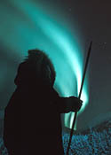

And then throw in the Russians maintaining their ever expanding electronic world in control in this area and there is no hope here. The Queen has stated that she thinks the electronic world is a form of backwards technology. When a person views the idiot commies trying to expand their hold on an area just because living creatures may be there, the Russians can be known for never stopping their kidfucking commie attacks on the free world. Reagan was wrong, overproduction doesn’t deserve to destroy Russia, but he forced their collapse. He was wrong by refusing not to outright bomb and destroy Moscow. Or not. (a very special study of a collection of ‘nots’, ‘refusals’, and ‘no ways’.)
St. Petersburg peoples act different, and trade the waters to England. Moscow however, is something I think any semblance of my Russian heritage ought to hate with a passion that makes them die in a life-less electronic coffin they always have fun with. Asshole Russians. I can’t wait for China to teach them a lesson. North America is too stupid to, and even helps them destroy a Japan that could control Russian imperialism, and it is Russian pig Imperialism …but my Mom reveres her ancestry, so usually I shut up. Russians are a bordello, they are a virus infected nation, they are the reason Reagan was depressed and in Altimers (old-timers?) disease, cause he couldn’t fully free us from them. And now the African commies think we owe them a life. Asshole commies ought to go back to their alien polygamist planets and stay there, not amoung the living.
So could high ‘phosphorescence’ also have a snap to it? I think Lake Manitoba is known for having high levels of ‘phosphorescence’ in it. The magazine for Western farmers called the Western Producer has reported studies that claim farmer run off of N, P, and K are in Lake Manitoba as phosphorous, potassium and nitrogen. What if that is inaccurate, and what if the green of Lake Manitoba is Uranium?
The prevailing winds from north Sk and Man could bring chalky uranium on the air to the south.
Tues March 26 2013 12 am / - 10 C only Orange is on the snow …from nls? No nls, H. Bay wind. Is – 10 C a nls threshold? Perhaps it is both too cloudy and warm for nls.
Wed, Thurs- exhaustion, other affairs are in order.
Fri – Good Friday- March 29 / 2013 No nls. And total cloud cover. Yesterday was very dark. Line defined clouds above ‘Almost Island’ to island cabin at mid- lake is joined by a line- clouds from the crotch of main hills across the lake. Very low clouds. As usual, (observed before, but only now recorded) and it is usual, the clouds joining my side with the hill side above the island cabin areas result in a very defined cloud border between the two clouds. The colder hill air goes below the warmer air on my side.

A small picture of the clouds meeting
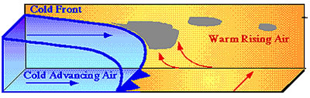
My side hillside
Since when does cloud have a border when it meets? This is different material, not just cloud meeting. I tried the best I could to make a picture, but the above was the best I could find.

Luke’s Observations of the Northern Lights

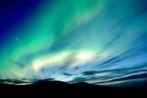

CHAPTER NINER:

The un-named 2000’ highpointed Stoney Mountains of Kug/ Coppermine to Churchill that hold the weather in, as in- ‘in’sanely cold (locally named).

March 30/ 2013 -20 C no nls.
It seems approaching spring here as it was 0 C yesterday. I wonder if both day and night temperature effects nls activity combined.
Binocular observations of the moon- I can see underneath of the usual area- usually three lakes are in a row at the moons mid-level, or equator.. Tonight the three lakes appear in the northern hemisphere. The moon is very iced over, irregularly shaped in the bottom right bulge.
So if the earth effluent collects in the moon and not as rings such as Saturn’s effluent perhaps a winter is fully weighing in on the irregular shaped moon with the bulge in the bottom right. How could the moon shrink again unless solar or reflected radiation keeps it a semi- constant shape? Why don’t Saturn’s rings fill up? Or solidify? You see, E Lake is science!!
Sun March 31/ 2013 -10 C 8:30 am
Exhausted – no nls. In am, and my back is gone again.
6:30- 8:30 I walked ½ way to the far end of ‘almost Island’ (connected only by an esker to the mainland). I was trying to go and stand in what I thought was a physical snowdog. I’ve been told it is impossible, but that is southern science. I’ve seen skyberg chicklets drop as fallout here.
The first 15 to 20 degrees of the sunrise on the horizon produces snowdogs and intense light beam activity directly below the sun- I’m probably wrong but maybe this opened up the ice on the far shore of the lake. This week, the sundogs are not at the same area and it cannot burn through the ice so the ice has reclosed. The sun is moving in its location due to the change of season, and taking the sundogs for a ride with it. The ice has reclosed.
Ya think I am nuts, eh? Solid laser ice? The ice reclosed due to the earth/ sun axis growing into a spring behavior as it must be said also that March has been cold. How else can I account for a lion of a month cutting open a swath of the lake? There have been some warmer days. I decided iI would walk into the sundog, but as told it disappeared as I got closer. So maybe south science has sway here, but I couldn’t start the fast moving snowmobile to catch the sundog either, due to back injury. So beam me up Scotty. The non- caring attitudes of the nuclear industry spill off into dangerous risk taking. They don’t care, and I start to also. Not a good thing.
Mon April 1st/ 2013 – 30 C 4 am
XPOND emanations and XGUN shoots (cracks?) straight into the sky- 2 lines about 500 feet each, separated by perhaps a 50- 100 foot gap, offset, but almost straight in a line with each other. A bit of a drift. Sundogs are split by the sun (star-ray) as are moondogs. Moondogs split marsh gas/ uranium gas but are sundogs gas? Is light vapour liquid?
How can water vapour / liquid be part of the water cycle of liquid- gas- solid? Light is water, we don’t know it because we live in it and all fish in a water tank think water is air, eh? We don’t know we are in it until we space travel, but even that is a controlled environment. Spaceship earth. Fishbowl earth. We don’t even know we are in it. -10 C yesterday, - 30 C tonight…is this too cold for nls? As a gas at least, green mist … {…I’m unsure what that meant…}
Yemen claim Shakespeare of England was a native of Yemen called ‘Sheik Casper’, or ‘Shakespeare’. I wonder if he ever saw hyperborean mists and pondered upon them…
6:30 am to 8 am {…illegible…}
9 am -15 C
10 am -10 C but it is + 20 C in my newly made window greenhouse that is off the ground and on an angle to reduce surface area on the low point to the cold ground. Wow, maybe now if I run out of firewood I can still survive. All I really have to do is go ahead and refuse to consult Az about creating a small room and heat sink in the small room on the inside of the window- the bathroom. I had plans to expand it to twice its’ size, but only made small markings with red insulation sealing tape to denote where walls need to be. I had no blue tape, only Ella Fitzgerald oldies. Green eggs and ham!
After the conservation officer visit, Az told me any construction efforts inside would be left to the carpenters. I’m so careful what I say with him it takes me a few phone calls I think to let him know that I worked carpentry labour before. Anyways, I’ve done what was required to survive so that was all I expected Az to approve of. So much for this place being my home.

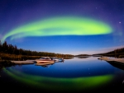

A moondog is a split of swamp gas/ Ur…is a sundog a splitting of gas/ lights? Nls last night, but no sundogs this morning. Are sundogs part of the Ur cycle or marsh gas to only occur and accompany the sun when nls hasn’t burned off the contents of the daily sky? Are areas of high sundog activity an offset for low or no nls activity? Is it one or the other? Do both portend ur/ swamp gas in the biome?
Mon April 1st / 2013 10 pm – 15 C
‘Almost Island’ emanations…{illegible} out to E Lake and making a large pile of nls between the hills and E Lake.
Tues April 2/ 2013 – 15 C
Not much out in the sky. Perhaps it all played out earlier when I was snoozing.
Wed April 3/ 2013 – 20 C northern wind
What if the sun is a form of nls? Nls directly overhead, gaseous, green, little flaring activity, just glowing green. INCREDIBLY GREEN!
Thurs April 4th/ 2013 – 30 C no wind
XPOND, Almost Island Bay activity (one of many locations…that was not an accurate thing to write…). Very broad south band. A very active night, no flaring or little – no wind to provide friction of flaring on biome surfaces.
Friday April 5th/ 2013 – 30 C north wind. Billowy broad band from XPOND to E Lake then defined strips of nls ‘pooling’ in center of the E Lake towards island cabin.
Friday April 5th /2013 – 30 C no sundog
Are sundogs occurring only at – 10 C? Do they occur only when nls do not? It seems that way- the nls gases go to Sundog form when nls are not possible. Temperature based or nls burns of substances that make sundogs, similar to moondogs. Know your sundogs by moondog behavior!

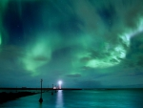

Sat April 6th/ 2013 – 30 C 2 am slight north wind
Full sky of lights. Colder= nls more active!
Some billowy, mostly bundling, flaring is not spectacular and lacking the yellow, so mostly I view green. ‘Bowl’ of light over E Lake northern opening over XPOND and all between. Double bands are across sky. Very cold/ active due to slight north wind in my opinion.
6am – 7 am - 30 C wind from both the north and from Whitehorse direction, not Lutselke, or Snowball/drift. Tallest sundog I’ve seen yet, ranging from rainbow colours to 1500 feet above sea level to 2000 feet with a white line above the rainbow collage. Put a wonder to mere words. Cloud covers my Lakeside, so no sundog appears there. This sundog is 2X higher as normal. (sundogs usually appear in paired-‘opposites’). If a sundog cannot express itself on both sides of the sun’s beam, does the sundog put its entire ray (vapour? liquid?) to the other side?
South science says sundogs can’t be substance, only light. But light can be water, and water can freeze. So sundogs can be frozen water. The sundog to reflect higher on ground here than they do when they are on the ice of E Lake. Moondogs split nls with a moonbeam. Why should sundogs be different?
Mon 8th April 3:30 to 4:14 am - 20 C WOW.
{just keep reading, because many things happened at one time}
The XGUN ‘fired or cracked a line and all activity in the sky ended. This coincides with a strong wind blowing in wind from Manitoba blowing north. I was doing sit-ups on the roof and tower area when all nls activity seemed to end. Even the holograms left the sky, either wiped clean on the ice surface of the biome or the Russians decided to stop playing their total world domination games using holograms in their electronic non-stop warfare they want to hide from democracy. Asshole Russians.
Holograms are a known technology.
I repeat, they both left the sky and are a known technology.
Within 5 minutes the XPOND is once again actively producing its swamp gas/uranium ‘pooling’ in the sky.
Wow.
Is the XGUN a particle beam? Did a nearby radio/ communications tower send out a microwave to clear the sky and also facilitate northern communications? Nls were very active before I came out, including a billowous long collection south of the cabin. So tired, just trying to get my exercises done. Hmmm…well, an interesting birthday I suppose!
{Too much occurs at once. The Billowous long cloud acts as if a giant chalkboard eraser, moving north, wiping out all in its’ path, then the wind changed, and the nls were active in a very short time again. There are other factors, as listed, but too much happened at once.}
April 9th Tues / 2013 12:30- 1:30 am – 10 C first – 15 C at 1:30 am
I’ve never seen the XGUN do this, or that (on April 8th) before. Maybe I’ve got to revise my XGUN thinking or theories on what the XGUN is. Or was it only the long billowous nls travelling north then south that erased the holograms? Like a chalkboard brush…
Little sleep – 4 hours 2nite. Clear minded, but also groggy and sluggish in muscles. But the south wind was moisture laden. It was a very warm, moist wind that could have sent this area into an nls carwash.
It has been ice winds the last few days from Dubawnt Lake or Resolute or Gjoa (‘Joe’) Haven (pronounced ‘Joe’). It’s all sheer chill and damn cold. And I do think I’ve mentioned that the area just north of me and to the coast contains a micro-climate in the winter only that drops another – 10 C from outside it. Partly due to being confined in the area by the un- named Stoney mountains, and partly to the effect of a series of lakes that maintain its epicenter (Dubawnt, Baker, and the one next to Baker) this area chills out.
Now HAARP project could have cleared the air by blasting it, but here is either a XGUN shot , moisture laden wind, or a tower relay that pulled a HAARP circumstance. HAARP being a technology for developing Tesla atmosphere science into a working submarine communication devise.
www.popularmechanics.com/technology/engineering/archiatecture/strangest-military-bases-gallery-HAARP-research-station#slide-4
I’m from the Toronto area in my youth, but outside of it in the isolation of southern Ontario.
I’ve studied mountain weather, which is hill weather even if only one hillside or horizon is tall. Cold air rushes down between 4am to 8 am to usually lower temperatures by 10 C. I lived in Fernie, BC watching this daily occurrence.
I experienced my third biome on the prairies in south Saskatchewan a biome devoid of trees.
The first year I lived in SK, south of Regina, a prairie fire burned 20, 000 acres west Weyburn. Swamps and marshes there stop the fire. Three days and 20, 000 acres were gone. My little town had a unique border river. The most rainfall in one hour in Canada fell just about 10 KM northwest at brooking. We also got tornadoes, but Brooking is a ghost hamlet. Did the locals find it too fierce to live in?
Ennedai Lake is my 4th biome. It has a low ceiling on the living biome, for many reasons. The Ministry of Natural Resources of Saskatchewan states E Lake is a part of a mini- area within the Canadian Shield called ‘Mudjatik” as well as in the Wollaston pre Cambrian domain boundary. Prevailing winds here extend from Saskatchewan at times, and perhaps deliver a sort of kaolin windfall from the Athabasca Basin. / boundary particularly is rich in base metals, with uranium and also lead- zinc, rare earth occurrences, copper-zinc, and iron formations (Spense lake). Madjatik has a ‘Nirdak Creek’ area bordering NWT that shows for gold but it also connects to Kasba Lake which empties into Lake Ennedai.
Prospectors are recorded in the caretaker log books as being here at the lake.
Wed April 10th/ 2013
My back is a bit off from the solar greenhouse building onto the window- a solar window sill! I didn’t know if I’d have enough wood to last the cold weather, or if as suggested, I would be leaving. Weather here and accidents can lead to plans being entirely ruined. My solar windowsill however, and the kerosene emergency heat could probably see me through until the summer or until, if all went wrong, that I would somehow use one of the boats to go down the Kazan and to Rankin where there is less isolation but still tons of fish for food. What great heat I have from that window sill…usually a modest 20 degree rise, but also more often a thirty degree rise.
Little nls activity, but greyish bands of nls from XPOND to cabin island area are in a wide
X……cabin open mouth style.
What type of communication tower is the one at Lake Ennedai? I’ve seen other straight line XGUN cracks directions, and simply thought electroplating and sluffing- off of reside was making the lines in the sky. But maybe they are bio dome cracks.

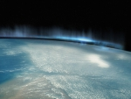

Luke’s Observations of the Northern Lights

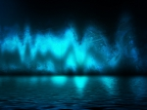

CHAPTER X:

Green mud forming around a small green chalky pebble- it’s a water-soluble-dissolving-pebble in a wet puddle.

Thurs April 11th / 2013 0 degrees 1:30 – 4 am strong south wind and no nls because it is too warm for the northern lights.
Sun April 21st Wow, a week lost. Don’t know how I’m going to survive if I leave here. I just want to stay but I have legal matters to attend to- proving I’m not one of seven fathers from a polygamist goon I was married to. I’m off to get parent testing done and to seek legal recourse to stop my Mother from suffering a ten to twelve year old lie.
Milky ribbons last night (-25 C) . Pooling at XGUN and XPOND areas.
Friday April 25th / 2013 – 20 C 11:30 pm wind {?direction}
Moon is rising Orange. White nls… or mostly white. {…illegible…}
Something shooting more lights into the sky from due east across bay. Many shooting stars have been seen at E Lake while I’ve been here but this white orange is unique.
Okay, so I would say that if you want affordable nls experiences, try going to and staying at Stoney Rapids, in North Saskatchewan, Canada. A few people have told me that the nls occur there also but none tells me of the occurrence of being silenced about them. I mean being awestruck. Silencing is I think a willingness to overlook poor measuring and testing qualities due to crappy Saskatchewan standards. Anyways, it is probably too warm near the Lake Athabasca to have icebergs in the sky there.
Natives won’t talk to certain white guys also, and even though I tried most my life to understand native cultures, they want to bait and chant to kill animals the way they also want to kill the earth. In Greek mythology the Earth is a person. So in practice, the natives want to kill the earth and have almost all people tricked on this. This is how they also trick animals when hunting them- pretending to be friendly.
In the 10% population of the North Am vegetarian world, we don’t have the problem carrying around such trickery guilt. But few in North Am don’t want slavery. Abe Lincoln himself didn’t care about slavery. He was losing the war he was fighting, so he decided the emancipation proclamation would win it for him. He was quite a fighter that fellow. But his heart wasn’t one to care about slavery. For two years he could not win his war, so he decided to champion slavery. Before that, Abe was happy with the white versus white conflict. Maybe the USA is meant to be different climate peoples. Maybe it’ll always have its conflict patterns due to refusal to allowing the south to separate.
So there it all has been, I’ve presented you with a bunch of my survival instinct as in a radiation environment. Galileo, Copernicus, Toronto board of Education, I’d say if you look for exclusive nls experiences, go to Stoney Rapids. They have a couple hotels, but they are not cheap. One has a diner with it.
A lot of non- mainstream info is in the air- Edward Leedskalnin’s ‘Coral Castle’ levitation of Homestead, south Florida, USA- right near Miami, but south. James Gardener also has a ‘Hollow Earth Theory’ that gets a person doubting a place where few actually have ever lived in physical authority. Tesla technology now is coming out and being claimed as from Berkeley, or Motorola, or from Roger’s wireless. His ‘black light’ technology is still however a mafia technology like x-rays that the public are not supposed to misuse in North America, but have no qualms about ill- use elsewhere. Radiation be damned. Japan shut all its’ nuclear power stations down with the tsunami that hit their coast recently.
I’ve questioned the nls as thoroughly as I possibly have been able to. The root cellar barrel in the sky concept makes people wonder about nls freezing and giving off light energy. Anyone have a clear freezer door on their refrigerator to watch this happen? No one has the time for this of course, and would rather be LinkedIn to the electronic world that be free, but that is in North America, not England. England still has a human monarchy trying to protect people from the Vatican and the electronic warfare the Russians pretend hasn’t submitted democracies the globe over.

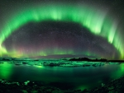

Different mineral content can make different lights, or rather light colours. I can’t forgive my English spelling of colour any more than my English literacy, respect for the non- communist concentration of wealth that prevents poverty, and my English respect for tea time.
Some prefer no questions, pretending it is survival, and it probably is a form of survival. Protecting truth and not lies and ignorance is a very unique way of living, but my mentors would tell me the world is not so pure. Actually, Barb Fisher would call ‘no questions’ as being…boring.
Sat April 27th / 2013 – 20 C 6 am Yellowknife wind.
Yesterday I saw orange clouds above both XPOND and across the E Lake hill area. White lights, or maybe they were shattered ice lenses…flared to orange. Usually green lights flare to yellow.
Sunday April 28th / 2013 ?/?/?
Single long orange cloud (150 feet) above XPOND during the day. Burnt orange in colour. Also there are burnt orange colour clouds above the hills across the lake. The burnt orange clouds are long and flat. They are not fluffy, of a full range of thundercloud puffiness. They are low to the ceiling, as in a smog cloud from the Inuit factory production of various machines and machinery that the Inuit have kept hidden from us all until this expose came out.
Do orange clouds glow green in the cold? This orange …is it rust from iron? Is it radiation? It has a rust look to it- pumpkin as the Benjamin Moore paint. A rock in the water of E lake that is very close to shore has been ‘rusted- out’. The water seems to have leeched the iron content over the eons, but the hollowed rock remains.
Further out the shore, are a series of low lying rocks that are barely above water level, and often lost in the snow level so I guess I don’t know the real water level after ten feet of water. What is the level after ten feet melts? Is it higher?
Other rocks on the lake, these flattened ones I’m talking of, they have light green but hard …what I would say is uranium. It may be jade, so I don’t know. But jade isn’t radioactive last I heard.
Or is jade actually a form of uranium, prized by even the ancient Chinese due to the ability to be radioactive? The Bagavagita Hindu text talks of ancient weapons from the sky that I think Arjuna throws down. Maybe the China/ Indian border wasn’t always defined as it is today.
It is okay for the entire world to be questioned, as the ancient sages have themselves proclaimed that ‘First, all is as it is, rock is rock, water, sky is sky. Second, rock is not rock, water is not water and sky cannot ever be sky. Lastly, rock is again rock. Water is water and sky is sky’.
So the ancients, immortals, mostly of both Greek and ‘Chinese- book- burn’ acclaim, are suggesting that questions occur, but patterns remain.

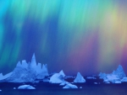

Monday April 29th/ 2013 – 20 C 3 am tsunami Yellowknife wind
This in an April. A storm of this magnitude the end of April. As stated before, Baker Lake has a unique, coldier than thou winter pattern.
Walkways clear yesterday area again 4 feet blown in. Visibility is 1 km. Tons of snow and whiteout conditions. If a bio dome freezes, it will crack like ice in a lake. When land quakes occur, as is noted on the mineral resource maps of north east Saskatchewan, what happens to the uranium content in cracking rocks?
The earthquake fault line (as if I don’t require another factor to juggle) is mostly in the top east/ right corner of Sask. Province, Canada. The fault lines run north south mostly, but above Athabasca Lake and Black Lake to the right of Athabasca are a series of east west fault lines at the Manitoba border. Is E Lake is a recipient perhaps of geothermal occurrences due to that fault line, or if not, then they are blocked by the Stoney Mountains.
If this quake line is active, then does it contribute to the Athabasca lake area being so warm on a day that E Lake can be so very much of an ice ball? Both cold and heat get trapped by hills, and the top corner of SK. Province is lined with them. This place isn’t Iceland from what I’ve physically seen, but it may be a uranium geothermal area. Are all geothermal areas Uranium radiation heated? Is Iceland another Chernobyl that the locals refuse to let the world know the truth about?
My direct question is can uranium radiation heat cause swamp gas content to rise, then skid over my biome?
Environmental factors are varied, but may lead to truth one day.
May 9th/ 2013 +5 to +10 C daytime temperature. It is overcast. Green mud on the airfield area occurs in splotches about 2 feet to a few inches in diameter as the airfield snow is melting. Green cake is also on the airfield. Green mud forms around a small green chalky pebble- water soluble dissolving pebble into a wet puddle.

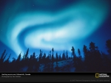

Epilogue

It is hard to imagine ‘ ice lights’. It is a beer, non? How can a log be made of pills? When it is an epilogue. Beer joke- I was just remembering being young and tanked. And the pills would have to be e-pills, or electronic pills. How could they be swallowed? Isn’t that a type of bird?
It is hard to imagine green snow or the incredible Hulk’s eyes on a human. My eyes go blue when I limit my diet. Grandma claims my older brother had golden eyes when he was born the very youth of his childhood. Grandma used to make a note of things, probably as a note to herself due to her fasting regime. She wasn’t a total abstainer I knew of, but who knows, she always cooked us a grand meal and would simply say she ate too much while preparing. She was a bit uppity that gal we called Ruby. She would have fit into the coming out day of Jackie Kennedy’s first social appearance. Grandpa after all was an industrialist that my Mother fled to my Father from…and his ‘Cuba deserves to humiliate America’ philosophy I cannot condone, living here most my life. Dad wants his catholic Indian commie crap. He’ll never have freedom.
But that makes me the black sheep of the family, or an ugly duck, or even a swan. Now that’s a bird.
I grew up in the silence of nuclear power energy in Kincardine, Ontario, Canada. Dissents of ‘nuclear’ were and are shut up for job security and psychological comfort. Nowadays Canada can’t keep up to France’s miniaturized reactors. Silence stops improvements from occurring, and Canada has perhaps lost its’ nuclear production of the CANDU reactor that was the talk of the town I grew up in. Kincardine was wonderful to grow up in in many ways. In other ways, silence stops improvements.

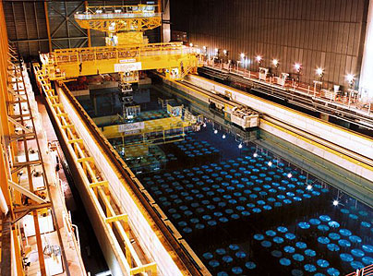

Japan recently made a shutdown of all reactors. Thirty six or so reactors, offline very fast after a tsunami knocked out only one. They know that perhaps there is a horizon on it with death if climate change is changing the ability of storms to end before severe landfall occurs. BC province has earthquakes and was the excuse for rabid BC never having the nuclear power. But Japan also has earthquakes and risked the power. Maybe they could freeze a biome or two and put the reactors where only Santa dares to go.
Lake Ennedai is a unique biome. On the tree line, or one of them, between taiga and tundra, it is a place that is perhaps similar to Yellowknife in its’ climate. People in Yellowknife have an observatory place for a business, and watch the lights there as a group. The Chipewyan name for the hills in this area is Stoney Mountains. Not the Rockies or the Smokies at Paulatuk. Stoney Rapids has nls, and a population of about 300 peoples. Knocking around ideas has helped me to fathom a science of this place, so you may think there has been extensive wandering, but this place is a wanderer’s epitaph or delight I suppose.

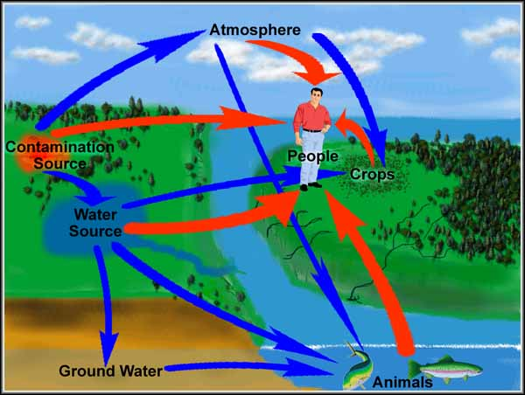

I think North Sask. has opted out for a newly formed silence on the radiation of Uranium so the locals all have as many jobs as are possible. Yellowknife has a greater infrastructure to view the lights, but Stoney may be more affordable for some. In Sk. Province, the Wollaston band was cut off welfare when protesting Uranium mining. It is perceived differently than my view of Fort McMurray being an ecological disaster that needs cleaning up, but I suppose anyone can say anything in the land of the imaginary freedom of speech. Imagine, Abe Lincoln didn’t care about freedom, but wanted only to win the war. Imagine Obama wants to be the Black Abe Lincoln. That means Obama wants racism. Such is politics, truth being the first casualty of corruption.
My Dad’s a doctor, and unconcerned if I have radiation sickness. He told me it was ‘my problem’ when I satellite phoned him asking simply what I can do to survive it.
He told me to shower it off, but I told him I cannot as all is contaminated h at E Lake. He didn’t respond to me saying I couldn’t escape it. As a writer I can suggest he didn’t know what to say. But he stole my inheritance and doesn’t deny it. He doesn’t like me.
Dad’s politically worried his former constituents will find out he doesn’t care if they are also in radiation sickness. As politicians hide things, he’s been in fine form. He doesn’t care if he steals from my inheritance with his new family collaborators, which makes me homeless more times than I care to recall. Cruelly, after stealing, he silences me with mental health crap. I don’t know how his homosexual submission behavior ever allows him to be of normal human appearance.
Gary Gurbin is part of the nuclear industry. Cancers in uranium refining is not something the industry talks about, nor are the birth defects of Elliot Lake’s Serpent River inhabitants that wind downhill from E Lake.

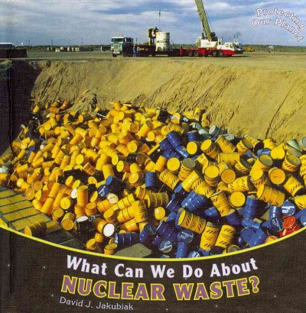

Few have correlated the north lights above Sudbury with Elliot Lakes’ mineral occurrences of uranium, but they occur. One other politician started his career in Ottawa after fixing Canada’s Uranium price to 60$/ ton, or price-fixed so. That was a fellow named something like Romanov, and he and Gary are political mafia, profit at any cost.
In Sk. Province and most of the Prairies, jobs to survive the cold make people throw out any other concerns of environmental hazards. Politics has no conscience even about destroying even about destroying the rule of law from which it is based upon.
I’ve told the current owner of Ennedai Lake that I think negligence was involved in his purchase of the property. He’s told me there is a land lease with the Nunavut government.
I’ve a Home Inspection diploma so I think I need to warn a client that there was a mishap or oversight in such a transaction. I know what a home can be and was quite content in Ennedai Lake in all my folly, but such is my father’s theft and bullying. He hates me for protecting my Mother and forcing him to face reality in their divorce. It just comes out in other ways while he plays innocent. If I also protect the Earth that Greek folklore considers human, or myself, his type thinks it is a joke.
C. Luke Gurbin
Father’s Day, 2013, pissed my ex scammed me. It ain’t my kid!
app2app@ymail.com

Conclusions and Future Vision
What if I say for you to consider options presented? I did have many pages of redesigned housing and the lodge, but that isn’t in the cards, so what good is me presenting you with a future that isn’t happening? In another perspective, today’s modern Japan has closed all nuclear plants. What I’ll miss is not building the lighthouse on the close-to-shore rocks.
I think if you have the D- gene, visit the place. If not, webcam it!

Weblist of ten pertinent northern light websites (which I often have little in common with)

- http://www.northernlightscentre.ca/index.html

- http://en.wikipedia.org/wiki/Aurora_%28astronomy%29

- http://goscandinavia.about.com/od/knowledgesafety/ss/northern-lights_3.htm

- http://weather.about.com/od/spaceweather/ss/topauroras_8.htm

- http://www.cbc.ca/sevenwonders/wonder_northern_lights.html

- http://www.northernlightsaward.ca/

- http://northernlightsbluegrass.ca/

- http://travelalberta.com/Things%20to%20Do/Nature%20and%20Outdoors/Northern%20Lights%20Viewing.aspx

- http://www.aqua-firma.com/countries/Arctic/

- http://www.nunavik-tourism.com/northern-lights.aspx

Here also again is my very own website (in case you link to Hemi-sync for free sound relaxation)
www.relax.moonfruit.com

Maps
Here are a few places you will find of use in this book, but they all forgot to call Ontario by its real name of ‘Funtario’.
Also forgotten were the other real names of the real Canadian…Canuckistan… areas. Red Fisher’s visit to E Lake inspires me to such eloquence.
- Mekon (closer to Cambodia in all but intent), and Ourkon, Hekon, Shekon, Weakon (pronounced as the phonetics-We ‘ a ‘ kuN- but with a staff in one hand, recycled-bag oil bottle in the other Ha’N’d).

- North Central and not at all West Territory (NWT or NCANAAWT),

- Somuvit, regions of Kivaliqmy… don’t let the Queen read this, Waterhawk region, and Blufflin’ Island (NT as in ‘nuts’ to drive anywhere on the snow highway?)

- Being Criminal (BC), or Born Callous. Not Bing Cosby, as these are the Russians that kidnapped his son, Bill, and trapped him in NY City. Base Crimeans. Bogus Crop.

- Nobert-ta (blending the olde Canadian ideals of French with the English while forgetting the Ukrainian, and the British always say ‘ta’ in Alber- ta. Nobert owns a bistro chain in London, Ontario.)

- Saskatchewannamakeasmallernamesoothernonnativepeoplecanwriteitouteasy? You wannatalkaboutHeadsmashedin or maybe you can read this another time.

- Womanitoba, (MN as in their HQ is Minnesota, where the Irish army marched from to help Louis Riel).

- Coo-Coobeckaramalamadingdong, (QB or not QB, that is the question, whether tis nobler in the mind to bear arms against a sea of trouble or to sleep. To sleep, perchance to dream. For in what dreams does QB steal from Ontario?).

- Oldelostwaters, (NFLD learned at an early age to fold his own linen)

- Peeinyourowneye, (PEIEIO)

- OldeArunslight, (NB, or IRVING barony the other Atlantics cast off) and also the well documented …

- Olde Scotland (NS, as in ‘has a ns day’ in zombie talk).

We won’t mention the USA is a Coo-Coo suburb of French ideals and high, very high bloody intellect. It cannot be said. Imagine any other nation on the earth with 3,500 religions all pretending to be separate from each other. Tanzania has it easy with maybe 500 tribes in total. And they have an Island, Zanzibar, just like New York. But they don’t conflict it with black supremacist racism, only with honest holy war that Russian commies deserve.
It is really nice that Malcolm ‘X’ decided to reject the Islam factor X. He could have stopped Detroit, Cleveland, and Buffalo rolling over into, and then rolling over the big apple.

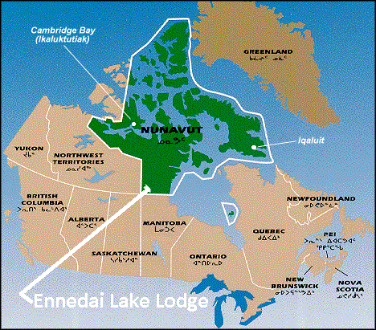

Oh where oh wear did my little nuke go, oh where oh were could it be? With its little metal casing and its uranium glow, oh where oh where could it be?
North Sk has 70 mines for Uranium. Half are closed for good or just simply not operating, but once they were. The government never connected the Uranium city are to the Alberta road system that runs to Yellowknife, so people are isolated where all the UR jobs were. Most UR mining seems to be around Wollaston Lake now, south and east of Lake Athabasca.
This map can predict where nls are, just imagine it is summer and the wind is blowing west to east. What is east of Bancroft? Montreal and its suburb called Ottawa (We all pretend the capitol isn’t in Quebec).

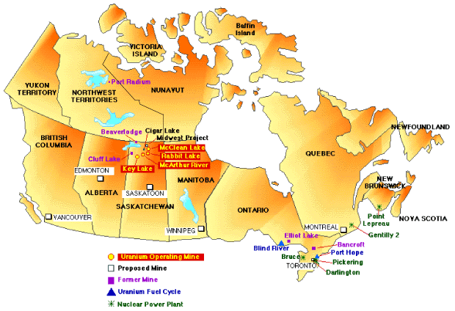

This gold map shows some few sites of relevance in understanding the Uranium in the water cycle, and also how Ontario is such a pro-nuclear area, even after the fact that Ontario has Canada’s brainpower.

Prevailing winds can determine a lot.
Most the west has prevailing winds that blow down and over, and if this can be said to be a factor at Ennedai Lake, then the Thelon basin blows down onto the E Lake area on a regular basis. I think the weather for this area is most like Lutselke, but only for three seasons. In winter, this region is its own colder weather than Lutselke.

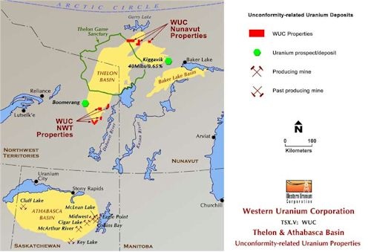

This map clearly shows there is a geology feature in north sask province that is being mined by the listed company, WUC. The same colour outlined in the regions north of Saskatchewan province suggest that the Thelon and Baker lake basins are also capable of uranium content, bu the map is unclear.
I’ve included the map to show there is mining company activity in the area, and that perhaps, as the owner Az has stated, that the people on the coast have decided against Uranium mining at the coastal areas of Hudson Bay.

Would you ever imagine spending 500$ (one-way) from Saskatoon to Stoney Rapids and then another $10, 000 (probably return) to Ennedai Lake on a charter airflight? I think the wealth that visits the north would astound me if I was an accountant.

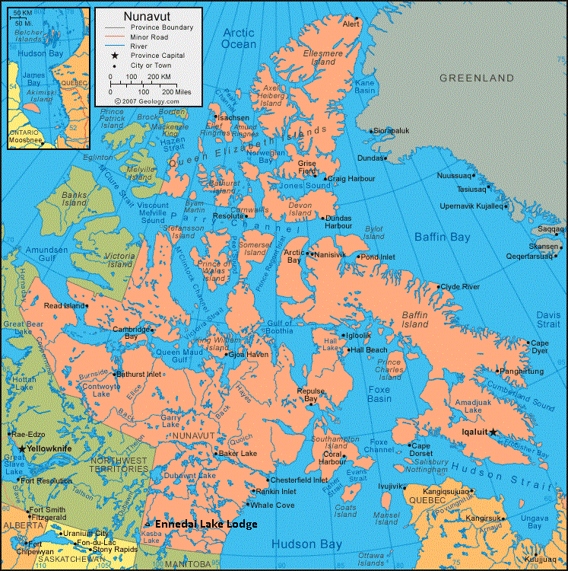
j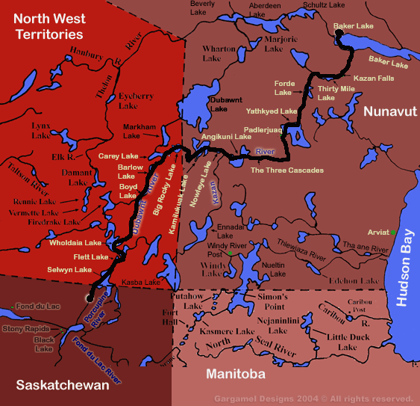

Here are the four corner provinces/ territories. They have it good in the Sates where they can just say ‘the four- corner states’ of Utah, Arizona, New Meheeco and Colorado.
From the air, in May, it seems the ground is only thawed out at Selwyn Lake, with the Porcupine River area when the topography is seen from above. NT is an iceball then, but Sk is so very warm you would think it was southern Canada. Indeed, when going to attend legal matters in the far south, it was warmer at Stoney Rapids than the cold air of the Mountains I tried to live in again.
You may not believe it, but the following are a few ‘back cover’ attempts, so this is the last word, echelon.

ICE LIGHTS

The sun is a radioactive pool of water that continuously makes a northern light.

If a grainbin sample can indicate the whole, the sun is water.

Galileo, Copernicus, Toronto Board of Education and Gurbin.

The Sun is water.

An incredible book with non-stop RADIOACTIVE DANGER!
RADIOACTIVE! RADIOACTIVE! RADIOACTIVE! RADIOACTIVE!

Amazing discoveries!
This is my northern epic ending in an eleven day fast- better not to eat than to die of radiation poisoning.

Notes compiled in the far north of Canada reveal how Uranium of Northern Saskatchewan and its’ close neighbours combine with water in the hydrology cycle.
Rebraking my back vertebrate ‘fusion- healing’ every time I chop firewood, after five months of being unable to pull- start a ski-doo revealed a unique northern science. I may be crippled, but canny!
Unplugging all digital sources possible (not the solar array) I wasn’t Robert Redford’s ‘electric cowboy’ nor was I living a pioneer lifestyle found in Louis L’Amour novels. I was on the cutting edge of a science of Northern Lights I’ve only seen at the nuclear power plant I grew up near. My community silenced me about nuclear as a youth, but I have a voice, one my Dad hates. Protect truth!

RADIOACTIVE RADIOACTIVE RADIOACTIVE RADIOACTIVE
Forget beer or drugs, buy this book and laugh silly all night!

