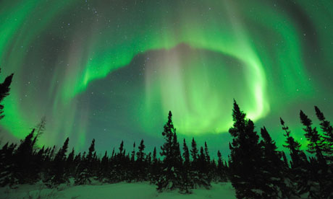

ICE LIGHTS

A book by C. L .Gurbin